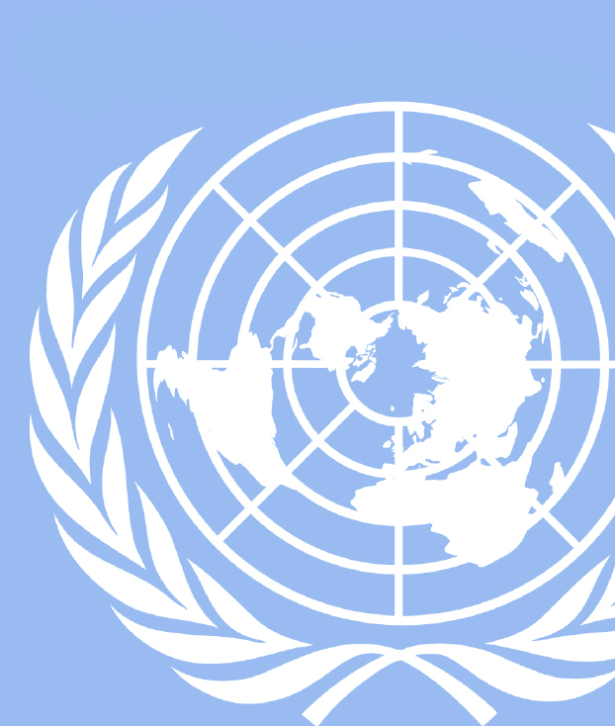
UGAMUNC XXIV
UNDP

Dear Delegates,

I’m pleased to welcome all of you to UGA’s 24th Model United Nations conference, UGAMUNC XXIV. Whatever your skill level or the number of conferences you have attended, we’re looking forward to having you and I’m confident you will perform well at this conference. During debate, you and your peers will have sufficient opportunities to discuss current global issues and ideal solutions. As delegates for the UNDP, The United Nations Development Programme, you will have the privilege of drafting resolutions on a diverse variety of topics such as the equality of jobs, foreign aid, and the accessibility to the internet with the approach from your respective delegation.

Before we begin discussing more policy, allow me to introduce myself. My name is Cameron Falk (ctf67235@uga.edu) and I’m a first-year intended Finance and International Business Major with a minor in Spanish at UGA. I competed in Model UN all four years of High School and have had the pleasure of competing at Georgia Tech, Georgia State, KSU, and UGAMUNC in 2016. While Model UN and schoolwork do occupy the majority of my time, I also enjoy watching movies, camping and playing tennis. During this upcoming summer, I look forward to studying abroad in Spain for my second time studying the Spanish language. Following my time in college, I hope to obtain a job in an Atlanta based business such as the Home Depot, Coca-Cola or Delta. I hope to take the public speaking and problem solving skills used in Model UN consistently to help me in work and my life in general.
I also have the pleasure of introducing my Co-Chair, Hiroki Kanai (hk92779@uga.edu). Hiroki is a visiting exchange student from Tokyo, Japan. He is currently studying Cognitive Neuroscience and Cognitive Science with emphasis on Artificial Intelligence at UGA. He has participated in 28th All Japan Model United Nations (The biggest collegiate competition in Japan), and awarded as Distinguished Delegate. He has also founded the Model United Nations Association in his home institute, in affiliation with the students of University of Oxford.

We are both ecstatic for this conference and the opportunity to meet all of you, along with hearing the varying ideas and approaches you’ll bring to debate. If at any time you have any questions about this background guide, your role, or the conference in general, please do not hesitate to contact one of us. As for now, you should be researching the positions taken by your country and each of the topics. The more you put into preparing for this conference, the better you will debate personally and it will better your chances of assisting your school in winning an award as well. We hope you’re all excited to begin debating these topic, and once again-Welcome to UGAMUNC XXIV!

Sincerely,
Cameron Falk
Chair, UNDP

History of the United Nations Development Program

Since the founding of the United Nations Development Program in 1966, its focus has been centered around “Sustainable human development”. Over the years, the UNDP works in coordination with over 170 countries and territories across the globe. By focusing on four areas of work: poverty eradication, gender equality, the environment, and good governance, the UNDP has structured its parameters of focus. While they have a wide variety of projects, their focus has been on eradicating the lack of services, credit, land, job opportunities, etc. Through the successful efforts of the UNDP: “Ethiopia emerged from nearly 30 years of civil strife with thousands of communities in need of rehabilitation, thousands of returning refugees and some 400,000 demobilized soldiers”, the UNDP has been expanding their outreach and level of effectiveness when helping develop countries.

With an uncertain future, the UNDP has been committed to developing the world and eliminating poverty once and for all for over 50 years. After merging with the Expanded Programme of Technical Assistance and the United Nations Special Fund, the UNDP has become more important than ever while helping develop nearly 170 countries across the globe. Since the UNDP’s creation of the “Agenda 2030”, which is their most ambitious set of development goals the program has ever agreed upon, they have continued pushing the development process across the globe. Through the use of their Sustainable Development Goals (SDG), the UNDP has prepared themselves for the long-term success of each developmental goal.

UNDP has arguably become one of the most valuable committees in the UN since its creation in 1966. The UNDP actively addresses expanding economic opportunities across the globe and improving the voice granted to the poor. The UNDP is also the active voice when natural disasters leave nations in the need of significant redevelopment support. In the process of being prepared for the onset of various world-wide catastrophes, the UNDP has come to understand the importance of development with a mandate of sustainability.

Delegates are expected to take into account these varying responsibilities and other additional factors when debating topics. The UNDP and the topics being presented are accurate representations of how different issues can become intertwined and overlap in their resolutions. The three following topics are a combination of current and past events that have real-life consequences for the present and future. If not addressed, the ramifications of each of these issues could potentially lead to heighted detrimental effects in the future. As a result, the United Nations Development Program has come to be a crucial facet of The UN’s presence throughout the world.

- Access to non-agricultural jobs for women in Northern Africa
Introduction

In the year 2000, approximately 189 member nations adopted what is known as the Millennium Declaration. This declaration targets key goals that United Nations summits and international conferences during the late 20th century agreed upon. Eight Millennium Development Goals (MDGs) were devised in order to structure the process of development. Within these agreed-upon measures, MDG 3 is specifically focused on promoting “gender equality and women’s empowerment”. This takes a hard focus on education, and more importantly, the employment of women in different jobs within the working sector. However, MDG3 interprets gender equality on a very narrow scale. The target the UN is striving for is linked to education but doesn’t address other crucial factors necessary to have true parity between genders and empower women.

Over the years, while globally the number of paid women in employment outside of agriculture has increased marginally, North African women remain trapped in an agricultural based bubble when it comes to job opportunities. Because of this it stresses the importance of addressing gender equality, and leads to further developments for women overall as stated with, “recognition by member states that gender inequality not only decreases the likelihood of achieving the other goals, but also that advancing gender equality”. In addition, the Women in the Middle East and North Africa (MENA) helps classify gender inequality in these regions and the true effectiveness of the efforts trying to reach gender equality. This classification is reliant on various human rights tools such as the UN Convention on the Elimination of All Forms of Discrimination against Women (CEDAW), as well as in the Beijing Platform for Action (BPfA) and UN Security Council Resolutions 1325, 1820, 1888 and 1889. Despite the use of these tools, the indicators that help determine the number of women earning wages in the non-agricultural sector are limited. They help display how much women can potentially earn on their own, but doesn’t account for women working in the agricultural sector specifically in Northern Africa that do not get paid. These are the women that informally employed by being unpaid family workers and as a whole, this group of women encompasses two-thirds of employed women in Northern Africa. As a result, it is necessary that these issues a dealt with through a body as large as the UNDP address these issues more effectively.

Background

In many Less Developed Countries, (LDCs) including those of Northern Africa, women make up a vast amount of the agricultural sector. In fact, those women “comprise 43 percent of the agricultural labour force globally in developing countries” causing a great dependency on the productivity of these women. Due to gender gaps involving agricultural productivity, one can observe an increased productivity level in agriculture by Northern African women. As the figure below shows, on average the number of women working in an agricultural field is between 40%-50% and this number holds true for much of Africa. With these numbers being so large, it makes the issue at hand very clear that these are the nations in need of the most help and need it in a timely manner. In Figure 1, shown
Figure 1: Female share of agricultural labor (%) by country.
on the right, the distribution of women in agricultural jobs by percentage in different Northern African nations. With a range of 24% to 56%, the number of women being forced in the agricultural sector is significantly high. Due to societies relying on the tradition of women filling various rolls in the agricultural sector, this sector of work provides itself with more means to continues its cycle. As long as society standards do not change, the cycle of
women occupying the vast majority of agricultural jobs will only continue.
Over the years, the rate of female participation in agricultural sector work in Northern Africa has grown faster than most other African Nations. Based on this quote: “These sub-regional averages have remained fairly stable since 1980, with the exception of Northern Africa, where the female share appears to have risen from 30 percent to almost 45 percent” the roles of women in agriculture have grown by 15%. Despite Northern African women’s participation in agricultural sector employment often disadvantaging them, their contribution to the agricultural output is undoubtedly significant. While these statistics can be used to grant a general idea of the situation, assigning agricultural outputs to gender is in general problematic. In most households, women and men both assist with agricultural production. In the same instance, it is known that women are often involved in the cultivation of certain crops while men are involved with others. With this understanding, researchers have been able to find the share of crops grown by women and men in the Northern Africa region to help show the reliance on women in the agricultural sector on average.
Worldwide, women on average represent less than 40 per cent of employment and encompass 57 per cent of those working on a part-time basis. In a 100 country study, data has shown that over one third of employed women work less than 35 hours a week in comparison with the 23.4 of employed men. In Africa, the underemployment for both women and men is high with gender gaps of 7.5 and 6.4 percentage points in this area. In a large number of Northern African nations this number is even higher along with up to 40 - 50% of this underemployment being out of total employment points, in those two regions. In some countries in sub-Saharan Africa, time-related underemployment for women is as high as 40 or 50 per cent of total employment.
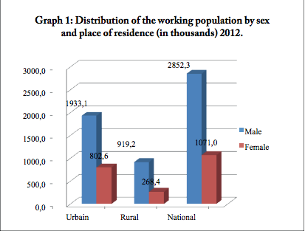
In addition to solely the participation rates of males and females as previously mentioned, there are major gender differences in the employment patterns of Northern African women within labor markets for several reasons. As a primary contributor, the result of child-rearing and household duties, women are far more likely to participate in self-employment activities instead of higher –paying wage employment. If women are to leave household activities, it is far more likely that they will work a subsistence farming job. Due to the child care responsibilities placed on women in Northern Africa, the women who are capable of being economically active often have to leave the labor market and accumulate less work experience. As a result of the many time constraints women face in this region, if women are able to have a job, it will typically only be part time, or some kind of informal arrangement. Because of this, they do not receive the benefits, experience or pay that they need to move away from the agricultural sector. Women can also become more concentrated in different phases of activities or the supply chain. This in turn creates occupational segregation into more low-technology occupations and limits the possibility of learning new skills; thereby hindering the professional development and only strengthening these sectors of low-pay and low-status job occupations.
Figure 2

Lastly, the pay gap that exists in urban area labor markets are also likely to exist in rural labor markets as well. Women are exposed to jobs with the need for comparable levels of education and experience but still do not receive the compensation of that of their male counterparts. As seen in Figure 2 to the right, this wage gap can be clearly observed between Urban and Rural areas of Northern African
Nations. Through this data, the issue of densely
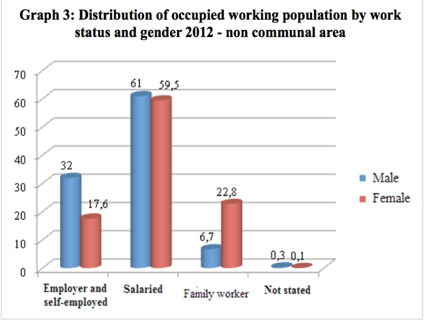
populated cities can be seen to have the most unequal job distribution overall. As seen in Figure 3, this graphic directly shows the vast amount of females still trapped in family worker jobs or self-employed jobs which leads to the significant number of females that become trapped in the unexperienced sector of the work force. In these instances, women’s most important sectors of work are: Industry, administration, and crafts, while men typically are involved with: trade, transport, services, construction or agriculture. Not only is the availability to work disproportional to the number of men compared to the number of women but the type of work itself is still of inferior quality to the female population in the Northern African Region.
Figure 3

Mitigation Strategies
Policy being developed at the national and international levels currently is attempting to mitigate gender barriers. While such policy is being put into place, oftentimes women are rerouted to areas traditionally occupied by women such as child care, health and social protection. That being said, women are also gradually being integrated into sectors of energy, water, and transport. While the ratio of men to women in these sectors are still severely skewed, they are being improved at much faster rates than ever before in history.
An additional factor that has become more accessible to women in Northern Africa is technology adoption. While still limited to primarily the household level, it has been continually increasing throughout the years. These advancements in the accessibility of technology for women, in future years will continue the integration process of women into different fields of work. As the skilled labor force of women improves, so will the available job options.
Over the years, development initiatives have specifically targeted women in development aspects like micro-finance, literacy courses, and market access. Studies evaluating these paths to empower women and the identification of gaps and challenges have been put into place. The evaluation of the labor constraints for women and other available opportunities has been the key to understanding women’s empowerment and its significance as a catalyst for national economic and social growth in a particular region. The effectiveness of these evaluations will likely be the exact determinants of whether or not future change will be implemented for women or not. In the process hopefully the necessary capacity at will be built varying levels of society.
Over the course of time, farming communities have taken significant amounts of adjustment to accept women into the business itself. For the women that are old or single, this process proves even more challenging. By following the guidance of their fathers or other skilled workers in their communities, a large number of women that would previously never have a chance to enter different fields now have an opportunity to do so. There are still many difficulties in place for women moving out of varying areas of the agriculture sector. For example, they are still faced with the reality that women make up much smaller labor groups in comparison to men and also cannot typically expand their businesses as easily and quickly as men. But nonetheless, with each of these advances, it still shows exactly how over time activities previously only available to men are now slowly opening up to women.

UN Involvement

Over time, the UN has become progressively more involved with assisting women integrate into the non-agricultural sector of Northern Africa. The UN has been helping push women’s attitudes in order to progress economic empowerment and over the years this has been one of the driving contributors to change. In many situations, due to local culture, women still perceive themselves as inferior to men and accept having fewer rights and opportunities than men. According to the sustainable livelihood framework developed by the Department for International Development (DFID) “Women’s power should come from inside”. As a result, the move towards increasing awareness for empowerment has been of utmost importance for the UN in order to encourage women to not only feel empowered as women in the workforce but as human beings.

In addition to the UN’s push for empowering women’s abilities in general, their push for increased education for women has also been one of the major improvements to the quality of life for women. Research conducted by the Settat community of Morocco on education of women and girls has reported that “literacy courses have allowed the use of mobile phones by rural women. This was perceived as a liberation of excellence by women”.

Lastly, alongside both education and the overall empowerment of women, the equity in access to resources is yet another key factor to improving the equality of jobs between men and women in Northern Africa. The empowerment of women in the rural and agricultural labor force has been affected by several factors. These include accessing financial resources, access to information, and the opportunity to join schools. On a much smaller level, the needs, opportunities, and conditions that determine the chances for women to gain employment, play a significant role in the long term effects on women in the future.

Future Strategies

Customs, traditions and religious beliefs are some of the most challenging obstacles that women face. The males of a community are often privileged where patriarchal structures dominate by supporting the existing social structures, taboos and perceptions of women that are regarded as common. The local policy makers are often not fully aware of the gender equality situation so policy makers changing the direction of their focus for the future in schooling in rural areas, training and capacity enhancement is crucial. Making these changes could drastically begin diminishing the poverty rates and improving the standard of living at both the National and International levels.
For future years, there have been proposed options for improving the empowerment of women in agricultural related activities that will undoubtedly help bring change in the future. Equal opportunity in choices, participation, knowledge of information and an increased awareness towards the ever changing attitudes of women’s work has been a growing point of improvement as well for the region by the UNDP. Many of these future advancements could be potentially achieved through changes in legislation, and the readiness to change the common attitude of women joining new sectors of the workforce. Both simple and complex attempts to change the situation have been made in the past, and an analysis of the experiences and interventions that have succeeded and failed each time can be used to generate more successful attempts later in the future. Hopefully, with each one of these components, gender equality and employment can begin to improve.

Furthermore, as with many of the other future solutions, the support of women with their continuous awareness of their conditions for the jobs their employed to, their rights as workers, and various medical related ailments that most governments do not take into consideration for women’s activities. Also, the future construction of more primary schools that lie in more secluded rural areas, this could help increase the chances of a young girl attending school and receiving an education. Those who are able to receive this education at such a young age will also be more likely to go to secondary school or a form of college education. In order to ensure this, the infrastructure needed for expanded school capacity and proximity to different geographic locations will without a doubt begin to improve the changing of the cycle for women.

Lastly, by developing gender-specific strategies, the UNDP could utilize different researchers, development agencies and NGOs in the area, women in rural areas will have a much greater access to non-agricultural jobs in the future. Through the process of ensuring the forms of agricultural labor, temporary, family, or the wages women earn for working in rural farm settings, the situation itself can be solved more easily and even more so with these improvements. Despite women’s work in agriculture is extremely poorly represented and in particular those jobs that represent National statistics. First of all, women’s work in agriculture are poorly represented by the National statistics but are still applicable to certain degrees. All in all, by creating and constructing a scheduled task and plan of action using these different points of improvement, the work for sectors of Northern African countries will be able to change from solely agriculture to women almost to a much more diverse area of work.

Questions to Consider

- What are some short-term and long-term solutions that can be used to help women trapped in the agricultural sector?
- What issues would be associated with intervening on the diversification of jobs in Northern Africa?
- What are additional ways to provide women in North Africa access to education in the hope of a continued education?
- How important is a change in the common culture associated around women leaving the traditional work sector?
- Can the international community be considered a source of causation of some of these issues of inequality?

Further Readings

UN Women analysis
http://www.unwomen.org/en/what-we-do/economic-empowerment/facts-and-figures

Informal economy of Northern Africa
http://www.ilo.org/addisababa/whats-new/WCMS_377286/lang--en/index.htm

Access to different jobs for rural women
http://www.ohchr.org/Documents/HRBodies/CEDAW/AccesstoJustice/FAO.pdf

Job equality
http://www.ohchr.org/Documents/HRBodies/CEDAW/AccesstoJustice/FAO.pdf

- Effectiveness of foreign aid to Mexico following the earthquake

Introduction

On September 7th, 2017 at 4:49 AM, a magnitude 8.1 earthquake was detected at the Gulf of Tehuantepec off the southern coast of Mexico. The capital of Mexico, Mexico City, is located 74 miles (120 kilometers) away from the epicenter of the earthquake. The nation's capital and surrounding area were devastated by this quake and tsunami. It was the most powerful earthquake in recent Mexican history. On September 19th, another powerful earthquake hit the island of Mexico; the epicenter of this quake was just 34 miles (55 kilometers) from the city of Puebla where 3 million people resided. Mexico City is one of the five states hardest hit by the two earthquakes, killing more than 450 women, men, and children, almost 60 percent of them in the capital city. Nearly 400 people were hospitalized nationwide. According to official estimates, over 34,000 households and over 10,000 schools were affected in the country.
United Nations Secretary-General Antonio Guterres expressed his sincere condolences to the people and to the government of Mexico on the dismal tragedy resulting from the earthquakes, while expressing the United Nation's willingness to assist. UNDP also announced that they will "advise on elements of economic recovery, particularly in the affected public markets and will facilitate the communities' involvement in the reconstruction of housing and key infrastructure".
United Nations Office for Disaster Risk Reduction
United Nations International Strategy for Disaster Reduction (UNISDR) was established in 1999. It is mandated by the United Nations General Assembly resolution to serve as the focal point for the coordination of disaster reduction and to ensure synergies among regional organizations and activities in socio-economic and humanitarian fields. It is an organizational unit of the UN Secretariat and is led by the UN Special Representative of the Secretary-General for Disaster Risk Reduction.
UNISDR and peripheral organizations adopted the Hyogo Framework for Action (HFA) in 2005. It is imperative for the international community to share knowledge from past experience to mitigate the damage stemming from natural disasters, and to create a common basis for disaster prevention. HFA is the inspiration for knowledge, practice, implementation, experience, and science for disaster risk reduction. As the world heads towards the end date of the HFA, it becomes increasingly important to outline an approach and form the discussions regarding an international framework for disaster risk reduction and resilience to be considered at the World Conference on Disaster Risk Reduction (WCDRR). As a result, the Sendai Framework for Disaster Risk Reduction 2015-2030 was adopted by UN Member states on 18 March at the WCDRR. The Sendai Framework is the first major agreement with the Post 2015 development agenda, with seven targets and four priorities for action.
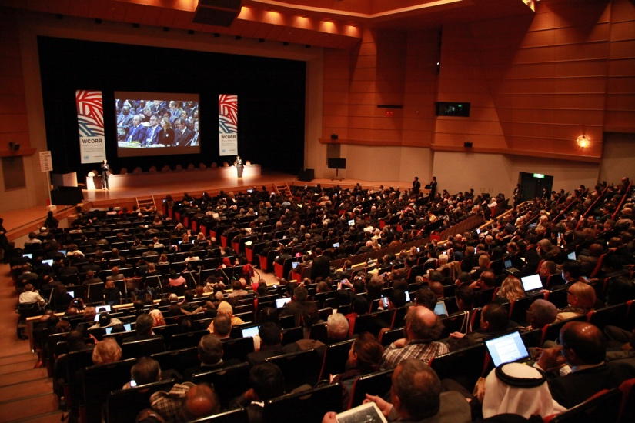
The earthquake in Mexico offers a timely opportunity to assess the effectiveness and issues of the Sendai Framework for Disaster Risk Reduction.
UN World Conference on Disaster Risk Reduction was held in Sendai, Japan to set out new framework for disaster risk reduction after the expiration of HFA

Risk reduction by aseismic infrastructure

The earthquakes in Mexico have caused devastating damage in Mexico City. According to the media, more than 40 buildings collapsed in Mexico City. This includes the collapse of the private Enrique Rébsamen school, which quickly became the most riveting emblem of the loss caused by the earthquake. City officials have begun an investigation to determine whether this incident was caused by a violation of construction codes.
The UN Secretary-General's Special Representative for Disaster Risk Reduction, Mr. Robert Glasser, mentioned on September 22, "This latest seismic tragedy underlines once more the truth that it is not earthquakes which kill people but buildings. Even Mexico City with its remarkable early warning system, and strict building and land use codes put place following the 1985 earthquake, this remains a major challenge."
As a matter of the fact, this is not the first time Mexico has face a seismic catastrophe of this scale. In 1958 an earthquake struck central and southwestern Mexico, killing more than 10,000. After this tragedy, Mexico equipped itself with one of the world's most effective early warning systems for earthquakes. Despite the implementation of this state of the art alert system, there were still issues in disaster prevention. The importance of investment in disaster risk reduction for resilience is repeatedly emphasized in Sendai Framework for Disaster Risk Reduction 2015-2030. As one of the priorities for disaster risk reduction, the article proposes to strengthen disaster-resilient public and private investment, in particular schools, hospitals and physical infrastructures. The aim is to build better from the start in order to withstand hazards through proper design and construction including the use of the principles of universal design and the standardization of building materials.

The Cancun High-Level Communiqué 2017
Mexico hosted the Global Platform for Disaster Risk Reduction in Cancun from May 22 to 26, 2017. The 2017 Global Platform was the first conference to provide a major opportunity for the international community to review progress on the implementation of the Sendai Framework for Disaster Risk Reduction.

Questions to consider
- What can international community provide when a natural disaster occurs? and What is difficult for the international community to provide?
- How can we make the most of the international foreign aid in both short term and long term?
- What is disaster risk reduction? and what particular actions UNDP preparing? How important is it for the international community to come up with a common base for natural disaster prevention?

Further Reading
Hyogo Framework for Action 2005-2015
http://www.preventionweb.net/files/1037_hyogoframeworkforactionenglish.pdf

Sendai Framework for Disaster Risk Reduction 2015-2030
http://www.unisdr.org/files/43291_sendaiframeworkfordrren.pdf

The Cancun High-Level Communiqué - Ensuring the resilience of infrastructure and housing
http://www.preventionweb.net/english/professional/policies/v.php?id=53439

- Improving the accessibility to the Internet throughout the Middle East

Introduction

Many Middle Eastern nations have identified the importance of internet and realize the role it serves in expanding nations into becoming knowledge-based economies. Internet and faster broadband internet is a crucial factor in creating economic development and the creation of new jobs in the economy. The expansion of the internet also brings with it new job opportunities, new forms of trade integration, and improved job opportunities. These internet networks are the backbone of connecting individual people, cities and regions together which leads to greater connectivity and the development of the economy. Internet and Broadband improve the productivity of various different sectors of the economy including: transport, energy, water, production industries, and consumer services. With increased access to the internet, sustainable growth can begin to take hold in the Middle East.
Although there is great potential to expand the internet throughout the Middle East, the region is falling behind at expanding the necessary infrastructure to have effective and encompassing access to the internet. Nevertheless, Social media is still on the rise along with other social networking features which help drive the need for more access to the web. Young people from the age of 15 to 29 years of age make up 75 percent of the Facebook users in Arab regions which totals 46,422,540 people. In addition to 2.17 million Twitter users, “80 percent of whom spend more than an hour each day updating their social networking channel”. Although currently only 0.162 percent of the digital content is Arabic content only, there is still a clear need for increased accessibility to compensate for the growing desire to stay connected.
Difficulties in reaching different target populations across the Middle Eastern region differ due to the variations in infrastructure and the disposable income available in the area and government finances. In the past and in present day society, the European Union (EU) has called for regulatory frameworks in this region to be put into place. The region would benefit greatly from the adoption of this framework in many ways, but would primarily expand as an economic market. Through the expansion of the internet in the Middle East, many century old issues connecting the people of the Middle East and the outside world could be easily resolved.

Background

As stated by Carlo Maria Rossotto, World Bank Information and Communications Technology (ICT) regional coordinator in the MENA region: “The Arab world is facing slower economic growth and high unemployment especially among young people and women. Broadband can radically change the socio-economic prospects for the region and contribute to higher growth and shared prosperity.”

Despite the great potential for expansion of society in the Middle East, there are still limitations associated with its expansion. Currently the cultural and political components of the region put numerous limitations on the expansion of the internet and its overall development. From the Western point of view, they are gradually limiting the growth of the internet and the possibility of any economic developments in the future. On the other hand, when political and cultural factors both come together they actually propel the expansion of the internet and therefore lead to the improvement of the entire economic system that the region has been desperately needing.
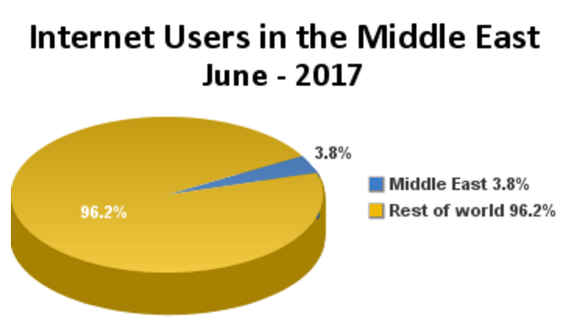
As shown in the figure to the right, the distribution of the internet users in the Middle East is nowhere near the amount of users throughout the rest of the world by any means. While the same cultural and political values remain in place, much the needed change to help promote the growth of the internet will never become a reality.
Figure 4
During the 1990’s, while internet outreach was still minimal and the availability of Arabic web pages was even lower, many obstacles were still in the way to creating development. Because of the lack of the needed digital infrastructure, lack of full connectivity across the region and the challenges drawn from the language barrier with Arabic. In addition, the many socio-economic factors, income and education differences were also major contributors to the differences in adaption patterns.
While many of the advancements in the growth of the internet in the Middle East appear to be very slow over the course of history, this was not necessarily due to the lack of understanding of the potential but the inconsistency of growth. As technology began to change rapidly during the early 1990’s, the Arab government approach was not as progressive as the technology itself. Due to rules and regulations, different forms of internet access only persisted to lag behind. Arab governments were still less concerned by the socio-cultural development but when Arab users began moving to the web to spread varying forms of propaganda and material considered illegal by the government’s standards did regulations and censorship begin appearing.

Mitigation Strategies
By growing the development and expansion of the internet in the Middle Eastern region, much of the economic lag and lack of further growth of the economy can be mitigated in various ways. Specifically, human capital can begin to expand through the increase in the access to the internet. With the possibility of increasing years of schooling, the job market, literacy rates, enrollment rates, and test scores from students, the increased access would have an influence on the ground floor to help lead to many more significant advancements in the future. With a rapidly expanding global market, these changes would help lead to significant advancements in globalizing the economies of Middle Eastern countries.
Greater efforts are needed in order to accelerate trade liberalization in the region as well. This would include: governance, transparency, and the overall quality of state institutions. This use of economic liberalization would help the use of fair and less restrictive competition and the market could decide where it would prefer to be allocative efficient. In order to be effective, these target goals would need to be aimed at transforming the businesses and overall atmosphere of the environment along with the integration of the region itself into the global economy.

UN involvement and Future plan

UNDP is especially interested in the capability and future potential of mobile technology. Mobile technologies offer portable, real-time communication and worldwide Internet access for people who could not get any access to affordable communication channels before. Since many companies in the IT industry invest in cell phone services in developing countries, the obstacles to making physical infrastructure available in underdeveloped nations are small and mobile devices can reach remote areas in a more cost-effective method than other ICTs such as Internet cables or fixed phone lines. Moreover, in some regions, mobile devices are the only feasible option of information and communication technology.
The Middle East is not an exception. According to the forecasts by Informa Telecoms & Media, the number of mobile subscriptions in the Middle East will cross the 250 million mark in 2012. This means that the average mobile penetration rate for the Middle East region will pass 107.09% at the end of 2012. As a result, mobile technologies are starting to have a significant impact on human development, enhancing democratic governance and other developing areas such as health, education, agriculture, employment, crisis prevention and environment. Research conducted by Indian Council for Research on International Economic Relations, has suggested that there is a correlation between mobile ownership and higher economic growth. Within governance, mobile technologies can offer new means for empowering citizens and other stakeholders by opening and enhancing democratic processes and mechanisms. This mobile government initiative that expands access to information and communications channels is creating a new venue for people's participation and giving new voice to those who have historically been marginalized. UNDP puts special emphasis on future development. Sustainability and scalability are still the main challenges to the strategic deployment of mobile technologies for development. Scalability issues are partly the reflection of a gap between what social innovators are doing on the ground and the lack of government action and the need to step in and support such initiatives. It is important to distinguish between the provision of private and public goods and services. The former tends to take off faster than the latter thanks to the involvement of the private sector. Broadening the scope of public administration and service delivery to reach the marginalized region public initiative, UNDP is actively organizing events and conferences with affiliation with local governments to promote private involvement in public ICT operation in the Middle East.
Questions to Consider
- How can ICTs used to accomplish UNDP's Sustainable Development Goals?
- How is it possible to promote interaction between public and private sectors in regards to ICT developments?
- How can international community ensure the sustainability and scalability of ICTs in Middle East?
- What are the possible prospects of mobile government initiatives?

Further Reading
UNDP. Sustainable Development Goals
https://sustainabledevelopment.un.org/sdgs

UN Billions of people still without internet
http://www.un.org/apps/news/story.asp?NewsID=51924#.Wfjc0JMrLEY

United Nations Development Programme. Accessed October 15, 2017. http://web.mit.edu/urbanupgrading/upgrading/resources/organizations/UNDP.html.
Ibid
"ON ITS 50TH ANNIVERSARY, UNDP IS LOOKING TOWARDS THE FUTURE." UNDP 50th Anniversary. Accessed http://50.undp.org/en/.
"About us." UNDP. Accessed October 15, 2017. http://www.undp.org/content/undp/en/home/about-us.html.
UNESCO, “Education for All Global Monitoring Report”, 2017. http://en.unesco.org/gem-report/
Chen, Marty . "WOMEN AND EMPLOYMENT IN AFRICA: A FRAMEWORK FOR ACTION." November 2008. Accessed October 15, 2017. http://www.wiego.org/sites/default/files/publications/files/Chen-Women-EmploymentAfrica.pdf.
Ibid
Doss, Cheryl , and SOFA Team. "The role of women in agriculture ." Food and Agriculture Organization of the United Nations . Accessed October 15, 2017. http://www.fao.org/docrep/013/am307e/am307e00.pdf.
Palacios-Lopez, Amparo, Luc Christiaensen, and Talip Kilic. "How much of the labor in African agriculture is provided by women?." Food Policy. February 2017. Accessed October 15, 2017. https://www.ncbi.nlm.nih.gov/pmc/articles/PMC5384444/.
Ibid
Ibid
Doss, Cheryl , and SOFA Team. "The role of women in agriculture." Food and Agriculture Organization of the United Nations . Accessed October 15, 2017. http://www.fao.org/docrep/013/am307e/am307e00.pdf.
UNIFEM, Progress of the World’s Women 2008/9 http://www.unifem.org/progress/2008/
Ibid
Palacios-Lopez, Amparo, Luc Christiaensen, and Talip Kilic. "How much of the labor in African agriculture is provided by women?." Food Policy. February 2017. Accessed October 15, 2017. https://www.ncbi.nlm.nih.gov/pmc/articles/PMC5384444/.
" Empowering Women in the Rural Labor Force with a Focus on Agricultural Employment in the Middle East and North Africa (MENA) ." September 20, 2011. http://www.un.org/womenwatch/daw/csw/csw56/egm/Martini-EP-9-EGM-RW-Sep-2011.pdf.
Chen, Marty . "WOMEN AND EMPLOYMENT IN AFRICA: A FRAMEWORK FOR ACTION." November 2008. Accessed October 15, 2017. http://www.wiego.org/sites/default/files/publications/files/Chen-Women-Employment-Africa.pdf.
Doss, Cheryl , and SOFA Team. "The role of women in agriculture ." Food and Agriculture Organization of the United Nations . Accessed October 15, 2017. http://www.fao.org/docrep/013/am307e/am307e00.pdf.
Ibid
Ibid
Ibid
"Women Entrepreneurs in the Middle East and North Africa: Characteristics, Contributions and Challenges." 2007. https://www.ifc.org/wps/wcm/connect/e3a45180488553abaff4ff6a6515bb18/MENA_Women_Entrepreneurs_ExecSum_English.pdf?MOD=AJPERES&CACHEID=e3a45180488553abaff4ff6a6515bb18.
Ibid
Ibid
Ibid
United Nations Development Programme. Accessed October 15, 2017. http://web.mit.edu/urbanupgrading/upgrading/resources/organizations/UNDP.html.
"ON ITS 50TH ANNIVERSARY, UNDP IS LOOKING TOWARDS THE FUTURE." UNDP 50th Anniversary. Accessed October 15, 2017. http://50.undp.org/en/.
Ibid
"Women Work and Welfare in the Middle East and North Africa." Accessed October 15, 2017. https://www.northeastern.edu/cssh/internationalaffairs/wp-content/uploads/sites/2/2016/04/Women-Work-and-Welfare-in-the-Middle-East-and-North-Africa.compressed.pdf.
" Empowering Women in the Rural Labor Force with a Focus on Agricultural Employment in the Middle East and North Africa (MENA) ." September 20, 2011. http://www.un.org/womenwatch/daw/csw/csw56/egm/Martini-EP-9-EGM-RW-Sep-2011.pdf.
“Women's key role in agricultural production emphasized." UN Women. Accessed October 15, 2017. http://www.unwomen.org/en/news/stories/2014/10/sharefair-rural-women-technologies.
Ibid
Most powerful earthquake in 230 years hits Mexico sparking tsunami. Web. Metro. Oct 13, 2017. http://metro.co.uk/2017/09/08/tsunami-warning-as-magnitude-8-earthquake-rocks-mexico-6911929/
Earthquake Hazards Program. U.S. Geological Survey. Web. Oct 13, 2017. https://earthquake.usgs.gov/earthquakes/eventpage/us2000ar20#executive
UNDP to support southern Mexico states as it builds back better after massive quake. UNDP. Web. Oct 15, 2017. http://www.undp.org/content/undp/en/home/presscenter/pressreleases/2017/09/28/undp-to-support-southern-mexico-state-as-it-builds-back-better-after-massive-quake.html
UN stands ready to assist following deadly earthquake in Mexico. UN News Centre. Web. Oct 13, 2017. http://www.un.org/apps/news/story.asp?NewsID=57577
Ibid
Who we are. UNISDR. Web. Oct 13, 2017. http://www.unisdr.org/who-we-are
UN World Conference on Disaster Risk Reduction. Web. Oct 13, 2017. http://www.wcdrr.org/
Sendai Framework for Disaster Risk Reduction 2015 - 2030. UNISDR. Web. Oct 15, 2017. http://www.unisdr.org/files/43291_sendaiframeworkfordrren.pdf
Collapsed School in Mexico Earthquake Is Checked for 'Hidden Defects'. New York Times. Web. Oct 16, 2017. https://www.nytimes.com/2017/09/26/world/americas/mexico-quake-school.html
UN: Mexico earth quake underlines importance of strict building codes to ensure safe schools and buildings
Mexico: Lessons from 1985 earthquake. UNISDR. Web. Oct 13, 2017. https://www.unisdr.org/archive/52756
Mexico's big switch to Sendai. UNISDR. Web. Oct 13, 2017. https://www.unisdr.org/archive/48765
"Local Solutions With Global Impact in the Middle East." Internet Society. September 11, 2017. Accessed October 18, 2017. https://www.internetsociety.org/blog/2014/03/local-solutions-with-global-impact-in-the-middle-east/.
"Access to High Speed Internet is Key to Job Creation and Social Inclusion in the Arab World." World Bank. Accessed October 18, 2017. http://www.worldbank.org/en/news/press-release/2014/02/06/access-to-high-speed-internet-key-to-job-creation-social-inclusion-arab-world.
Ibid
Ibid
CGCS . "10 facts about internet use in the Middle East." World Economic Forum. Accessed October 18, 2017.
Middle East Internet Statistics, Population, Facebook and Telecommunications Reports. Accessed October 18, 2017. http://www.internetworldstats.com/stats5.htm.
"Internet in the Middle East: an asymmetrical model of development." Taylor & Francis. Accessed October 18, 2017. http://www.tandfonline.com/doi/full/10.1080/24701475.2017.1305715?scroll=top&needAccess=true.
Ibid
Ibid
"Challenges of Growth and Globalization in the Middle East and North Africa by George T. Abed and Hamid R. Davoodi." International Monetary Fund. Accessed October 18, 2017. https://www.imf.org/external/pubs/ft/med/2003/eng/abed.htm.
Ibid
Mobile Technologies and Empowerment: Enhancing Human Development through Participation and Innovation. UNDP. Web. Oct 18, 2017. http://www.undp.org/content/undp/en/home/librarypage/democratic-governance/access_to_informationande-governance/mobiletechnologiesprimer.html
Technology Leaders Launch Partnership to Make Internet Access Available to All. Facebook Newsroom. Web. Oct 18, 2017. https://newsroom.fb.com/news/2013/08/technology-leaders-launch-partnership-to-make-internet-access-available-to-all/
Ibid
Middle East mobile subscriptions ready to boom. ITP.net. Web. Oct 18, 2017. http://www.itp.net/mobile/587166-middle-east-mobile-subscriptions-ready-to-boom
India: The Impact of Mobile Phones. ICRIER. Web. Oct 18, 2017. http://www.icrier.org/pdf/public_policy19jan09.pdf
Mobile Technologies and Empowerment: Enhancing Human Development through Participation and Innovation. UNDP. Web. Oct 18, 2017.
Ibid.
Ibid.
MCIT and UNDP Launched the 'Internet of Things' to Support Person With Disabilities. Egyptian Street. Web. Oct 18, 2017. https://egyptianstreets.com/2017/09/07/mcit-and-undp-launch-the-internet-of-things-to-support-persons-with-disabilities/

