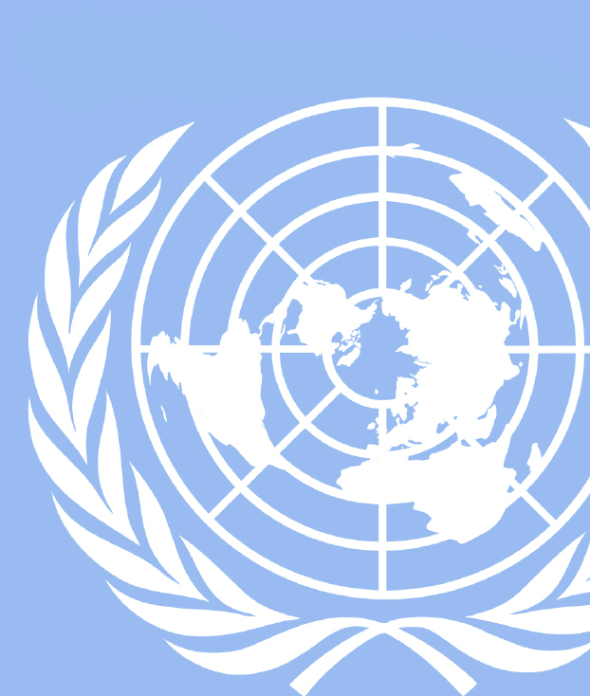
Hello Delegates!
UGAMUNC XXIV
CDC

Welcome to the 2018 University of Georgia Model United Nations Conference. My name is Esther Osinaiya and I am so happy to be your Crisis Director this year for the Centers of Disease Control and Prevention Committee. I will be running the committee with your chair and co-chair, Mohammed Ahmed and Rahul Katkar. I had the opportunity to intern at the CDC the summer after my freshman year so I am super excited.

Before I go any further explaining the crisis committee, I would first like to introduce myself. I am from Atlanta, Georgia and a senior studying Finance at the Terry College of Business here at UGA. This is my 4th and final year on the team and I have had the wonderful opportunity of being the Finance Director. Outside of Model UN, I am involved in various business organizations such as NABA, SEO, and Woman in business. I also enjoy talking about music and films and I host a radio show on our campus radio station.

Your chair for this weekend will be Mohammed Ahmed. He is a second year Computer Science major with a passion for Model UN’s heated debate. Mohammed chose to chair for the CDC committee because of its unique perspective and potential for huge consequences. In his free time, Mohammed loves playing board games with friends as well as solving puzzles. In addition, he enjoys playing soccer and badminton with other UGA students. He can’t wait to see the creativity the delegates will bring to committee.

Your co-chair for this weekend will be Rahul Katkar. Rahul is a 4th year biochemistry and linguistics major interested in medicine but intrigued by international politics and diplomacy. As he has researched infectious diseases (particularly malaria) for almost four years now, it seemed appropriate to contribute to a committee designed to tackle them. Rahul enjoys classical music, dancing, and dank memes as well as fast cars and slick motorcycles. He is excited to view how this committee will tackle this specially-crafted crisis.

As you all start preparing for committee, I highly recommend that you all take advantage of this background guide’s information about the CDC’s history and your characters. This guide does not contain everything for you to be an exceptional delegate in committee, so it is important to do research outside of this amazing guide if you wish to stand out. You are all expected to be creative and smart about the direction you take this committee and tackle the various crisis that will be thrown at you. If you have any questions contact me at eoo88996@uga.edu.

Good luck!
Esther Osinaiya
Crisis Director, Centers for Disease Control Committee

Starting Scenario: The Outbreak

URGENT!!!
Priority Mail: EXPRESS
Official CDC Mail Enclosed
To all those it may concern:

The Center for Disease Control is requesting your presence on (Date of UGAMUNC) at the CDC’s temporary headquarters in Athens, Georgia in order to respond a developing issue. Enclosed are details specifying the situation. Your expertise and knowledge within your field may prove invaluable to addressing the subject in question. This matter is strictly confidential and as a result our expectations are of utmost discretion.

Regards,
Mohammed Ahmed
Director of the Centers for Disease Control and Prevention

The Outbreak
The CDC is at present facing an unparalleled threat, which we do not fully know the consequences of. While the CDC’s responsibilities include ensuring the safety of the American people and combating the spread and creation of deadly diseases, we are intensely interested in disease outbreaks abroad. The U.S government has become aware of an extremely virulent disease outbreak occurring in China. The CDC is presently referring to the illness as, Disease X.

At present, we know very little about the situation in China. The Chinese government has imposed a heavy lockdown on the region using the military to physically limit access inside and outside of the affected area. In addition, the Chinese government has imposed a gag order on the state-run media as well as deploying The Great Firewall in order to completely contain all information.

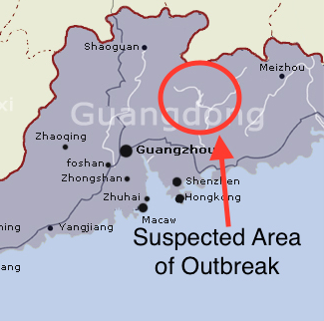
Confidential Intel:
Using our reconnaissance satellites in the area, we have been able to determine the general location of the outbreak as Southern China, in rural parts of Guangdong province. Presently, we do not believe that Disease X has spread to any of the surrounding major urban centers, but as a result intelligence is utterly lacking.

Currently, we have no understanding of how the disease is transmitted, its symptoms, or how lethal it ultimately is. However, we do know that its rate of transmission is particularly high and it is currently threatening to spread to nearby urban centers.

Congress and the President of the United States are awaiting this committee’s recommendation in determining how large of a threat we are facing as well as how to proceed. Because many American citizens are visiting China and the nearby region, the U.S. government will have to make a statement soon. In addition, the United States’ response will be closely watched by all members of the international community.

Because of the volatile nature of the situation, every second counts in this race to protect American lives. Since many of you delegates are not members of the CDC, you will have the opportunity to support the CDC in its pursuits with your specialized knowledge and experience, as well as performing peripheral duties, whereas members of the CDC will be able to call upon many of the arms of the United States government for support. Ultimately, this committee’s purpose is to gather as much information on Disease X as possible nd to take the necessary steps to prevent the outbreak of an epidemic.

Questions to consider while preparing for committee
Short term:
- What steps will you take to learn more about the unknown disease?
- How will you balance both domestic safety and international aid in order to maximize results?
  - What relationship, if any at all, do you want to establish with China and the international community?
  - How will you keep the United States public’s fears in check while informing them of the threat?
Long Term:
- What are some of the interests of your character and what can you do to not only avert this crisis, but prepare yourself for future crisis? (You have creative freedom here)
  - How do you want your respective organization’s (i.e CDC, NIH, WHO, etc.) role to evolve by the end of committee?
  - What can you offer to the committee in terms of resources and power?

Formation and History of the Centers for Disease Control

The Centers for Disease Control is the main federal agency, within the U.S. Department of Health and Human Services, that protects the public health and encourages safety among U.S. citizens. The Centers for Disease Control was established in 1942, with its headquarters in Atlanta, Georgia. At that time, it was known as the Malaria Control in War Areas. Its purpose at the time was to control the spread of malaria near military training bases in the United States by killing mosquitos. By the end of World War II, CDC founder Dr. Joseph Mountin and the U. S. Public Health Service’s Bureau of State Services, wanted to create an agency to support existing state units in identifying and controlling disease outbreaks. There was fear the the CDC would step over the boundaries of the National Institutes of Health (NIH). To avoid this, the CDC decided to focus on the control and prevention of diseases while the NIH would dealt with scientific research.

Over the years, the CDC has expanded to combating all infectious diseases, noncommunicable diseases, injury and environmental health, health statistics, chronic disease prevention, and occupational health. In the past, Malaria was a major threat to the nation’s security now however, new threats like West Nile virus, Ebola, Zika virus, E.coli, and bioterrorism are being tackled by the CDC. The CDC is one of the very few Biosafety level 4 laboratories and one of the two repositories of smallpox in the world. The Centers for Disease Control also reaches overseas by coordinating with health agencies to prevent emerging disease epidemics. The CDC is now a national and international entity that fights the continuing battle on diseases.

Responsibilities and Duties

The CDC’s three primary functions are to protect the health and safety of U.S. citizens, inform the general public to supplement healthy decisions, and to promote health through partnership with state health departments and other related organizations.

The Department of Health and Human Services, which the CDC is a branch of, has the statutory responsibility of limiting the formation and spread of communicable diseases in the United States. The CDC’s Division of Global Migration and Quarantine is responsible for this. Their activities include operating quarantine stations near port entries, establishing standards regarding medical examinations for individuals entering the United States, and administering interstate and international quarantine regulations involving the movement of people, animals, and modes of transportation. The federal government's isolation and quarantine authority comes from the Commerce Clause of the U.S. Constitution.

Both isolation and quarantine can be used to protect the general public from being exposed to contagious diseases from people who may have it. It is important to understand the difference between isolation and quarantine. Isolation is the process of separating those infected with a contagious disease from people who are not. Quarantine restricts the movement of those “exposed” to a contagious disease to monitor if they progress to being ill. Isolation and quarantine are also “police powers”, meaning states can take actions to protect their state borders regarding health, safety, and welfare. Laws can vary state to state.

Federal isolation and quarantine occur via an Executive Order of the President. The CDC monitors those arriving in the U.S. for signs and symptoms of communicable diseases. For example, the CDC can detain passengers on a flight to determine if their illness is a communicable disease. They may enlist or assist state and local authorities in enforcing quarantine and isolation. In the event of a conflict in certain actions between federal and state law, federal law is supreme. Breaking a federal order on quarantine can result in fines and imprisonment.

Organizational Structure

Though the Centers for Disease Control is headquartered in Atlanta, Georgia, it also has 10 other locations in the United States and Puerto Rico. The CDC is divided into centers that focus on specific cases referenced below.
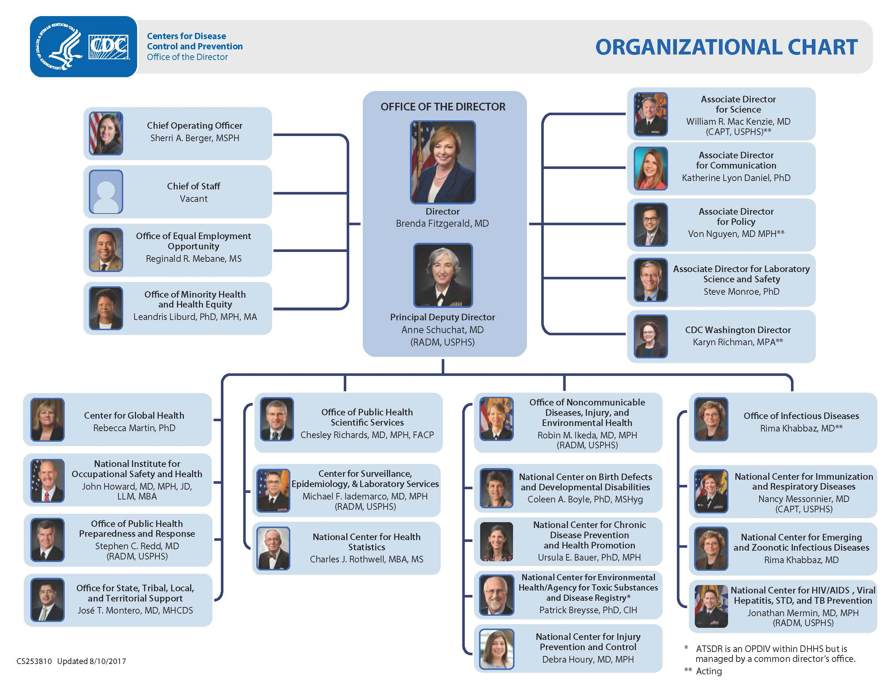

National Institute of Health Importance to CDC

The National Institute of Health(NIH), is a part of the U.S. Department of Health and Human Services. Its role is to be the nation’s medical research agency by making scientific discoveries to protect the health of those in the U.S. They conduct and support research to investigate treatments and cause of diseases. NIH efforts to collaborate with HHS agencies like the CDC, are important in translating scientific information to knowledge based approaches.

USPHS Importance to CDC

The Commissioned Corps of the U.S. Public Health Service can be traced back to the U.S. Marine Hospital Service that prevented the spread of diseases from sailors returning from international ports and monitored the health of immigrants in the country. Currently, the USPHS is involved with delivering health care to underserved and vulnerable populations, disease control and prevention, research, response efforts to disasters, and other public health concerns. CDC has a role in protecting the public from chemical and biological terrorism. The Commissioned Corps officers of USPHs are assigned to various programs throughout the CDC. Over half of the medical officers within the USPHS are assigned to the CDC.

Pan American Health Organization

PAHO is a specialized international health agency under the World Health Organization to support the Americas. PAHO actively works with public health leaders in the targeted regions to fight diseases, respond to emergencies, and strengthen local health systems. Their philosophy is to ensure that everyone has access to the quality healthcare they need. PAHO encourages technical cooperation between countries and partners with other government agencies, ministries of health, international agencies, and other partners to continue to ensure public health is a priority.

CDC Relations with China

The Centers for Disease Control and the Chinese government have worked together on public health concerns that impact China, the United States, and other nations for over 30 years. The CDC focuses on emerging infectious diseases, HIV/AIDS, global health security, laboratory quality and safety, and other public health concerns. The CDC normally provides China with scientific information in order for China to support themselves and other developing countries.

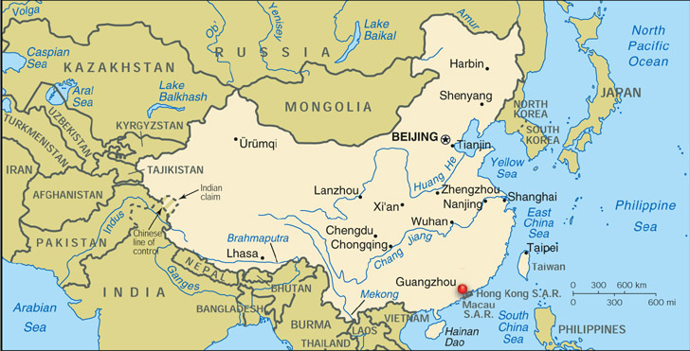

Basic Rules and Procedures for Crisis Committees

This committee will be organized in a ‘crisis committee’, so we will not be following exactly the traditional rules and procedure of a General Assembly committee. The majority of you may not be familiar with this committee style, however, crisis committees allows delegates to be more creative and fast paced in decisions and responses. We are still operating under UGAMUNC rules, but below I have outlined key things to understand regarding crisis committee style.

1. No speaker’s list. We will be operating using constant moderated and unmoderated caucus. No topics will presented, therefore not agenda needs to be set. Our committee will start debate based on the starting scenario
2. Character assignments. You have all been assigned a character prior to committee. It is important that you read and understand your character’s bios in the background guide, in addition to doing any research that could supplement your debate. Remember that all your actions and decisions should best represent what your character would do in the situation and crisis.
3. Crisis notes will be used. Crisis notes allows you to get information and take actions without the knowledge of your entire committee. You should use crisis notes to get closer to personal goals and exercise the powers you have based on your position and occupation in committee. Examples include, but are not limited to getting funding, creating connections by writing to fake or real characters, getting information about those around you, and writing a personal directive (individual action to help with problem). The most successful crisis notes are the ones that are very detailed including who, what, when, where, how, and why. Every action has consequences, so before you decide to make any MAJOR actions, build up to this action by pacing your crisis notes and making sure there is no weakness in your plan that could be used against you. These crisis notes will be written to the crisis director and do not require any approval or signatures from others. Remember to address who your character is and the specific person you are writing.
4. No resolutions. Instead of writing resolutions to solve issues in committee, directives will be used instead. Directives tend to be more concise and less formal versions of resolutions that attempt to solve the current crisis that the committee is dealing with. Like crisis notes, they still need to be detailed in order to be successful. Any delegate(s) can start working on a directive as soon as the committee begins debate. However, directives written prior to committee will not be accepted. Directives are committee wide actions and still require a majority vote.
5. Additional Committee wide actions. Other committee wide actions include communiqués and press releases. Both are written more formally than directives. Press releases are used to sway public opinion, provoke public reaction, or inform the public of a committee decision. Communiqués are used to negotiate, threaten, or ask for support from another body.

A Note on the Structure of the Committee

The crisis committee structure functions the same way majority of collegiate style committees do. This will give you the opportunity to experience what many other college “MUNers” face during our competitions.

This will be a fast-paced committee: crisis updates will be presented to committee regularly and it is expected that they be solved promptly.

As the Centers for Disease Control, you as a body have a large influence in resolving the current problem. It is imperative that you all work together and use your individual roles and resources to contribute to the issue at hand. The crisis director looks favorably upon the combining similar directives in an effort to maximize efficiency. Take advantage of writing notes to your fellow delegates during debate and unmoderated caucuses to avoid redundancy. Note: Read about others members in your committee beforehand

It is highly encouraged to reach out to the crisis director staff with notes and personal directives. Awards will be determined by what goes on both inside and outside debate.

Positions papers will be required for this committee in order to receive an award. Your position paper should explain what approach your character will take in committee to solve the outbreak including both personal actions or how you plan to interact with other delegates. They must be submitted via email a week in advance.

It is expected that everyone in committee be respectful to not only your chair and co-chair, but to the other delegates. We will not tolerate any offensive language or actions. Avoid rude and malicious comments while discussing topics, people, or regions during debate. This includes and is not limited to racially targeted genocide/murder, offensive stereotypes, or any forms of hate speech.

Finally, be prepared to have fun. We do expect for you all to follow rules and structure of debate, but there will be a lot of excitement due to the nature of crisis committees.

Character Biographies:

Private Academic Research labs
Professor Richard Laws of Harvard School of Medicine Emerging Disease Lab
Born in Pearl Harbor Naval Base in Hawaii, Dr. Laws was raised in a military family. Dr. Laws realized military service wasn’t in his future after being diagnosed with Savant syndrome. Dr. Laws decided he would focus on researching diseases that threaten Americans. His research focuses primarily on east Asian tropical diseases and has led four expeditions (one in Sumatra, two in Heibei, and one in the Guangdong province). Dr. Laws is an avid supporter of cooperation with the Chinese public health departments but is openly skeptical of Chinese policies on handling disease. Privately, he is not a fan of the Chinese government and believes they are inherently anti-American. Dr. Laws conducted nearly half of his expeditions with the CDC and has made great allies with former military members who trust his expert opinion. Dr. Laws has published articles in Cell and is an almost regular contributor in Nature.
Professor Isabella Castille-Rodriguez of University of Chicago Global Health and Disease Lab
Professor Castille-Rodriguez was born in Guadalajara, Mexico and legally emigrated to Chicago when she was 8 years old. Born to a pediatrician mother and public health researching father, Dr. Castille-Rodriguez attended Harvard for her undergraduate degree and Johns Hopkins for medical school before finally becoming an academic clinician. After ten years, she earned a masters in Public Health at her employer, University of Chicago, where she has expanded her research of tropical diseases to include public health aspects. She has many friends and former colleagues in the CDC who trust her expert opinion hence why her invitation to this panel. Dr. Castille-Rodriguez is a contributor to the Chicago Tribune Science column and has published numerous articles in Nature and Science.

National Institute of Health Characters
Director of the Office of Extramural Research Jonathan Sainz
Dr. Sainz is a former pathologist and commander in the U.S. navy. His major responsibilities include funding scientific endeavors promoting scientific integrity, public accountability, and program stewardship.¹ His main goal is to only fund expeditions that are scientific and would look good in the public eye. Dr. Sainz is a very type-A person who puts his faith in proper planning and organization and despises disorder. Many have called him the best director of the OER as he is very strict in choosing recipients of grants but is very generous in the grant amounts.

Head of the Office of Financial Management Sarah Parkman
Mrs. Parkman is an ex Goldman Sachs accountant lead. After learning cutthroat methods of getting work done and balancing budgets, Mrs. Parkman applied for a minor position in the NIH. After years of impressing colleagues, Mrs. Parkman was promoted to the head of Financial Management. Faced with a constantly shifting budget and unpredictable grant requests, Mrs. Parkman has to manage the budget to ensure nothing inefficient gets chosen. As she is under Dr. Jonathan Sainz, she naturally works well with him but does not fear speaking against his wishes. Her life motto: “if it’s cheap and works, it works for me!” has become somewhat of a mantra for her office.
Director of the National Institute of Allergy and Infectious Diseases Jason Whitmann
Dr. Whitmann is a newly appointed director. After a successful 35 year tenure under Anthony S. Fauci, Jason Whitmann seeks to leave his mark in funding research for diseases plaguing citizens of the world. Dr. Whitmann graduated top of his medical school class at Northwestern Feinberg School of Medicine and has worked in clinical research medicine for nearly his entire career. Under the guidance of Dr. Fauci, Dr. Whitmann learned how to control the NIAID’s massive $4.9 billion budget. Often called brash by his colleagues, Dr. Whitmann is not afraid to push for projects that may seem dangerous as long as they provide the end goal of discovering disease mechanisms.
Director of the National Institute of Environmental Health Sciences Linda S. Birnbaum
Dr. Birnbaum leads both the environmental health sciences and National Toxicology programs. Her position focuses primarily on environmental factors of disease and what sort of diseases are worth funding. Dr. Birnbaum was a federal scientist for most of her career and thus is quite familiar with federal methods of handling problems. Being a well decorated scientist, she has the the advantage of deference from most scientists she speaks to. Her research focused on environmental chemical effects on the body and toxicant action mechanisms. The NIEHS is focused primarily on prevention of the spread of disease and the training of activists. Safety is the utmost concern of the NIEHS and Dr. Birnbaum will ensure any project that she funds is safe. The NIEHS states “The fulfillment of [a healthy society] requires the partnership and effort of everyone in the environmental health sciences communities.”

Healthcare Providers
Ascension Health Senior Vice President and Chief Strategy Officer Eric S. Engler
Mr. Engler is CSO of the largest nonprofit health system in the United States, Ascension. As a member of the Catholic health system, they provide methods of healthcare designed for specific factions of the population but are inclusive of all demographics. Mr. Engler’s determination to ensure Ascension completes its mission for healthcare for all brought him from previous management roles at Reuters and Bridge Information Systems inc. as well as numerous other large corporations. Mr. Engler’s duty is to ensure the CDC has a knowledgeable healthcare provider who can give feedback on ideas and accept suggestions.
Trinity Health Chief Clinical Officer Daniel J. Roth
Dr. Roth is responsible for handling Trinity Health hospital system’s clinical operations. As an MD himself, he is poised to ensure patient comfort during stays at Trinity’s facilities, as well as proper handling of clinical operations and preparedness. As a doctor with extensive experience with patients, he is invited to provide a doctor’s perspective as well as another voice of a large healthcare provider. Dr. Roth is truly a patient focused representative in this CDC committee.
Kaiser Permanente Chief Community Health Officer Bechara Choucair
Dr. Choucair is in charge of the health efforts and philanthropic activities that Kaiser Permanente is well known for. Kaiser is a unique health provider that ties insurance with healthcare but does not discriminate in insurance plans for their patients. It serves 11.8 million diverse patients as well as 65 million people living within Kaiser provider locations. Dr. Choucair (MD) has the responsibility of ensuring Kaiser provides the best healthcare for their populations as well as managing funding efforts. With history as commissioner of the Chicago Department of Public Health, Dr. Choucair serves as not only a representative from one of America’s largest providers but also a voice from a doctor who has worked in a public health office. Dr. Choucair led the CDPH into being the first nationally accredited city public health agency. Dr. Choucair received his MD from the American University of Beirut and is a Lebanese immigrant.

CDC Offices
CDC Liaison to the WHO Savannah Mason
Dr. Mason worked in the diplomatic mission with the UN for the Secretary of State prior to joining the CDC. As the chief health advisor in the UN mission, Dr. Mason (PhD in Public Health) has worked with and grown relations with health advisors from all over the world including China. Dr. Mason has worked in the CDC for almost 5 years now and has offered many opportunities to work with foreign public health organisations. She is a firm believer in delegating work to others and allowing the U.S. to lead efforts.
CDC Liaison to the U.S. Agency of International Development Ray Jefferson
Mr. Jefferson works with the agency whose goal is to develop foreign countries’ in the name of the U.S. Nearly all of his work has been focused on aiding allied countries in combating disease. Specifically, he was involved in Romania, India, Turkey, formerly Pakistan, and Philippines. Out of everyone in the committee, Mr. Jefferson is the one with the most knowledge with foreign relations. His experience with allied countries gave him a Sinoskeptic attitude. However, his duty to focus on the development of allied democratic nations requires that he keeps relations in mind whenever he advises any public health community.
Deputy Director of the Office of Public Health Scientific Services (OPHSS) Chesley Richards
Dr. Richards has the important duty to organise and run the OPHSS. Dr. Richards has experience with the Immunization Services Division in the CDC. Dr. Richards went to medical school at the Medical University of South Carolina after he earned an MPH in Health Policy and Administration from Chapel Hill. He has experience in Internal Medicine, Geriatric Medicine, and General Preventative Medicine and Public Health. His quote “effective systems that put the right data and information in the right hands, at the right time, in the right format…to take effective public health action.” highlights his philosophy to employ only the most effective strategies and not waste time and effort on other inefficient methods despite political or personal reasons.”
Head of Center for Surveillance, Epidemiology, and Laboratory Services (under OPHSS) Michael F. Iademarco
Dr. Iademarco is a former physician-scientist and lab expert. Dr. Iademarco (M.D) is known for having networks with laboratories around the U.S. Dr. Iademarco’s office provides the CDC with valuable tools, expertise, skills, and services for disease control and prevention. Dr. Iademarco has experience pushing for the elimination of TB, working for the US Department of Health and Human Services at the US mission in Vietnam (where he was awarded a medal by the Vietnamese PM for fighting HIV/AIDS), and writing guidelines for TB prevention. Dr. Iademarco’s experience with field research affords him the abilities to encourage direct medical research missions.
Director of the National Center for Health Statistics Charles J. Rothwell (under OPHSS)
Mr. Rothwell was previously an IT expert in the late 80s before he became director of the Division of Vital Statistics. His extensive history with health statistics ensures he runs the best statistics for all of the CDC and America. Over his career, he’s been called for helping Peru, East Germany, and the UN for developing health statistics programs. His accomplishments include developing health statistics computer programs the National Science Foundation, numerous state governments and National Institute of Standards and Technology. Mr. Rothwell is a retired captain of the U.S. Marine Corps.

Director of the Office of Public Health Preparedness and Responses Stephen C. Redd
Dr. Redd (MD) is responsible for public health preparedness and response. Dr. Redd was director of the CDC’s Influenza Coordination Unit and worked during the H1N1 pandemic. Dr. Stephen Redd is a Rear Admiral for the USPHS and became an Assistant Surgeon General in the USPHS. Rear Admiral Redd has experience handling outbreaks like Legionnaires’ Disease, malaria, and also contributed to eliminating measles in the U.S. A well published scientist with 120 publications and numerous awards both military and civilian makes him a highly respected member of the CDC and the medical community.
Deputy Director of the Office for State, Tribal, Local, and Territorial Support Jose T. Montero
Dr. Montero (MD) is tasked to support various facets of the American healthcare system including health departments, tribes, and insular areas. Born in Colombia, he received his degree from the National University of Colombia. Dr. Montero served as vice president of population health and health system integration at Dartmouth where he developed his expertise at healthcare/strategy/system reform. Dr. Montero is a proponent of evidence based medicine and prefers rapid response allowing him to maintain New Hampshire’s status as America’s healthiest state. Most of his policies focus on reforming healthcare to becoming more efficient and easily accessible to the general public.
Deputy Director of the Office of Infectious Diseases (OID) Rima Khabbaz
Dr. Khabbaz (MD) leads CDC’s national infectious disease centers by focusing on molecular detection. Dr. Khabbaz has experience as director of National Center for Immunization and Respiratory Diseases and National Center for HIV/AIDS, Viral Hep, STD, and TB prevention. Dr. Khabbaz’s quote “In this highly connected world, microbes continue to challenge us, both here and globally. We must use the best expertise, science, and technology available to detect these threats quickly and respond as effectively as we can.” exemplifies her focus on molecular detection and prevention. Dr. Khabbaz is known for her leadership during disease outbreaks such as West Nile, SARS, and monkey pox. She is also known to be the leader of the team who responded to the anthrax attacks in the capitol building in 2001. Dr. Khabbaz emigrated from Lebanon where she graduated from medical school in the American University of Beirut.
Head of National Center for Immunization and Respiratory Diseases (under OID) Nancy Messonnier
Dr. Messonnier (MD) is known for her strong leadership, management skills and focus on staff. Disease prevention and immunization are focuses of hers as well. Dr. Messonnier played an essential role in vaccination of millions of people in the African Meningitis Belt, in the 2001 anthrax threat, and in anthrax vaccine development. She has also been important in disease surveillance initiatives and futuristic lab techniques for defending against diseases. She is well awarded and has published over 140 articles.
Head of National Center for Emerging and Zoonotic Infectious Diseases (under OID) Sanjana Patil
Dr. Patil is newly appointed and took over from Dr. Khabbaz’s former position as NCEZID director. Sanjana Patil emigrated from India where she graduated with her medical license from Lata Mangeshkar Medical College in Nagpur. She has extensive experience researching microbes and parasites from tropical areas. Dr. Patil’s polite demeanor is often mistaken for a lack of strength but she has shown herself to be quite the vocal speaker on passionate topics. Her focus on microbiological methods of researching diseases has made her famous throughout the scientific community.
Head of National Center for HIV/AIDS, Viral Hepatitis, STD, and TB Prevention (under OID) Jonathan Mermin
Dr. Mermin (MD) is known for his effective approach for HIV prevention called High Impact Prevention. This focused on health equity and research activities to lower incidence rates. Dr. Mermin worked with the Department of Health and Human Services in Kenya’s US diplomatic mission where he lead CDC’s largest foreign office. He has published over 150 articles and currently teaches at Emory University school of Public Health as well. HIs office is focused primarily on the four types of diseases in its title; however, these four diseases can often mutate rapidly.
Deputy Director for the Office of Noncommunicable Diseases, Injury, and Environmental Health (ONDIEH) Robin M. Ikeda
Dr. Ikeda (MD) leads the CDC’s four non-communicable disease centers. Her agency is focused on non-infectious diseases. Mental health, effects of marijuana, and hearing loss are some examples of entities this office would face. Dr. Ikeda focused primarily on injury prevention in the youth before this position. She has experience with infectious disease offices within the CDC as well. Dr. Ikeda is also a Rear Admiral in the USPHS.
Director of the National Center on Birth Defects and Developmental Disabilities Coleen A. Boyle (under ONDIEH)
Dr. Boyle (PhD) began her career in the CDC studying the effects of Agent Orange. Her expertise on birth defects and child health/development makes her one of the most knowledgeable in the field. She has contributed greatly to the CDC’s work on newborn hearing and congenital heart disorder screening. She currently leads the CDC’s autism research. Dr. Boyle has twice received the CDC’s highest award for scientific excellence as she has written numerous outstanding publications.
Director of National Center for Injury Prevention and Control Debra Houry
Dr. Houry (MD) leads research for evidence based solutions for injury prevention. Dr. Houry has served as a physician at Grady Memorial Hospital in Atlanta as well as been an associate professor at Emory University. Dr. Houry has received numerous awards for her work on injury prevention after writing more than 90 publications
Head of National Center for Chronic Disease Prevention and Health Promotion (under ONDIEH) Ursula E. Bauer
Dr. Bauer holds the position for chronic disease prevention. She is a PhD in epidemiology. She is tasked to ensure citizens can safely live their lives by preventing dangerous entities from hurting them. She has extensive experience with epidemiology and environmental improvements to improve health
Head of National Center for Environmental Health/Agency for Toxic Substances and Disease Registry (under ONDIEH) Patrick Breysse
Dr. Breysse (PhD) is tasked to investigate the effects of environment on health. He has extensive experience with environmental health, published over 242 peer-reviewed articles in popular journals, and participated in over 25 scientific meetings in the past 5 years alone. His research focuses on control of chemical, biological, and physical factors of health especially on risk and exposure. Dr. Breysse is on the editorial review board for the Journal of Exposure Science and Environmental Epidemiology.
Director of Global Health (CGH) Rebecca Martin
Dr. Martine (PhD) has experience leading the CDC’s mission to eradicate polio globally. Dr. Martin accelerated disease control for diseases with vaccines and introduced new and underused vaccines as well as improved immunization techniques. Dr. Martin has a lot of experience working on global projects with the CDC and has thus worked with the WHO and UNICEF for over 15 years. She has worked in Haiti, Kenya, Tanzania, and Denmark. Dr. Martin has connections in multiple ministries of health and non-governmental health organisations. Dr. Martin worked for the European Regional Office of the WHO to maintain its health. After that, she was detailed to the Africa division where she was tasked to evaluate the HIV/AIDS epidemic.

Director of National Institute for Occupational Safety and Health John Howard
Dr. Howard (MD) is also the administrator of the World Trade Center Health Program with the US Department of Health and Human Services. As an appointed position, Dr. Howard was unprecedentedly appointed for a third time for this position after being a popular and successful leader of the NIOSH. Dr. Howard had experience with the health divisions of the California Department of Industrial Relations, Labour, and Workforce Development Agency. Dr. Howard is also a member of the U.S. Supreme Court bar being an expert witness numerous times. Dr. Howard’s main priority is that his employees and American scientists under the CDC are safe from any possible danger.

World Health Organization Representatives
Deputy Director of the Pan American Health Organisation WHO-extension Isabella Danel
Dr. Danel (MD) is a former CDC official on maternal mortality and international public health who now leads the Pan-American division of the WHO regional offices. Dr. Danel has extensive work in disaster preparedness, corporate communications, strategic planning and budgeting, and external relationships. Dr. Denel has experience with the CDC’s regional offices in Central America and being an active physician in Central America with specialties in tropical medicine.
Director of Administration Gerald Anderson
Mr. Anderson handles financial resources and management of the PAHO, general services operations, human resources, IT, and procurement services. Mr. Anderson also oversees strategic initiatives for the region. Mr. Anderson held positions in the U.S. department of state as Officer of Peacekeeping, Sanctions, and Counter-Terrorism. Mr. Anderson has extensive relations throughout the world (especially in South America) and will provide the key to the communication with the Chinese. Mr. Anderson served in the Peace Corps, as a Diplomat, and as a Counselor for Political Affairs in Warsaw, Poland.
Assistant Director Francisco Becerra Posada
Dr. Posada (PhD) is a Mexican national serving to coordinate efforts in Family, Gender, and Life Course in the PAHO. Dr. Becerra Posada is also tasked to lead Communicable and Noncommunicable Diseases and Health Analysis and Mental Health, as well as Health Systems and Services. Dr. Becerra Posada graduated with a doctorate in public health focusing on research efforts. He has experience aiding developing countries improve their health infrastructure. He is also the liaison to the National Institutes of Health as well as a former consultant to numerous international organizations giving him access to networks throughout the world. He is also well known for numerous publications.

CDC - Office of the Director
Associate Director for Policy Von Nguyen
Dr. Nguyen aids in deciding the overall policy of the CDC. In addition, he serves as a middleman acting as a liaison between the CDC and the various outlets of public health and health care delivery system services. As such, he has ties to to the National Institute of Health as well as the periphery health programs and organizations under the umbrella of the government. In addition, he has experience working with Medicare and Medicaid as he served as a member of the Center for Medicare and Medicaid Innovation on the State Innovation Models. Lastly, Dr. Nguyen served as a consultant for a number of Fortune 500 companies and acted as a medical director for Doctors without Borders.
Associate Director for Science CAPT William R. Mac Kenzie
Captain Mac Kenzie serves to promote “leadership in science innovation, research, ethics, and science administration.” Much of Cpt. Mac Kenzie’s role in the CDC revolves around ensuring accountability and safety within the U.S Health Department. As the Associate Director for Science, his job involves raising health and safety standards through research as well as serving as a Quality Assurance manager to many of the policy changes that are implemented within the CDC. Despite his important domestic role, Cpt. Mac Kenzie also works to support the CDC’s mission internationally by working with other international health bodies such as the WHO.
Associate Director for Communication Dr. Katherine Lyon Daniel
Dr. Daniel is in charge of supporting the CDC 24/7 in protecting America from any and all threats domestic or abroad. As Director of Communication, Daniel serves as the glue that connects the various internal offices within the CDC. Her job entails maximizing strategic contact within the CDC and helping maintain the CDC’s public image. In addition, she is responsible for making sure that the research findings and programs run by the CDC are easily available and digestible for the general public.
International Disease Liaison Dr. Cameron Peshawar
Dr. Peshawar serves as a foil to the Associate Director for Communication. Whereas Associate Director for Communication has authority over the internal workings of the CDC, the International Disease Liaison serves to connect the CDC with the myriad of international and multinational health and safety organizations. In addition, Dr. Peshawar’s responsibilities extend to ensuring the CDC’s influence within the international community. Furthermore, he ensures that the CDC is addressing the needs of the international community and vice versa.
Associate Director of Food Safety Dr. Anne Young
Dr. Young is the head of a newly created Office within the CDC. As a result, despite her title, her responsibilities have not yet clearly been defined. She is responsible for ensuring food quality standards for any food imported into the United States, but she does not currently have the full authority to carry out her duty. The current crisis is seen as a testing phase for the new office and it’s future as well as her job remains uncertain.
Associate Director of Emergency Preparedness Dr. David Chen
Dr. Chen is a researcher that only recently turned CDC staff. Consequently, one of his main focuses is simulating different emergency scenarios and evaluating the CDC’s ability to effectively quarantine and handle it. The current crisis serves as a prime opportunity for his department to gain valuable data as well as objectively assess the CDC’s preparedness. Moreover, during times of relative stability, Dr. Chen is responsible for maintaining and raising the CDC’s emergency prowess and might.

"Centers for Disease Control and Prevention." Centers for Disease Control and Prevention - New World Encyclopedia. http://www.newworldencyclopedia.org/entry/Centers_for_Disease_Control_and_Prevention.
"About CDC 24-7." Centers for Disease Control and Prevention. July 22, 2015. https://www.cdc.gov/about/history/ourstory.htm.
ibid
"From Humble Beginnings: The History of the CDC." Premedmag.org. March 30, 2015. http://www.premedmag.org/2015/03/03/from-humble-beginnings-the-history-of-the-cdc/.
About CDC 24-7." Centers for Disease Control and Prevention. July 22, 2015. https://www.cdc.gov/about/history/ourstory.htm.
"Centers for Disease Control and Prevention." Centers for Disease Control and Prevention - New World Encyclopedia. http://www.newworldencyclopedia.org/entry/Centers_for_Disease_Control_and_Prevention.
ibid
"From Humble Beginnings: The History of the CDC." Premedmag.org. March 30, 2015.
"Centers for Disease Control and Prevention." Centers for Disease Control and Prevention - New World Encyclopedia.
"Specific Laws and Regulations Governing the Control of Communicable Diseases." Centers for Disease Control and Prevention. March 21, 2017. https://www.cdc.gov/quarantine/specificlawsregulations.html.
ibid
ibid
"Legal Authorities for Isolation and Quarantine." Centers for Disease Control and Prevention. October 08, 2014. https://www.cdc.gov/quarantine/aboutlawsregulationsquarantineisolation.html.
ibid
ibid
ibid
ibid
"Centers for Disease Control and Prevention." Centers for Disease Control and Prevention - New World Encyclopedia.
"About CDC 24-7." Centers for Disease Control and Prevention. August 10, 2017. https://www.cdc.gov/about/organization/orgchart.htm.
"Who We Are." National Institutes of Health. https://www.nih.gov/about-nih/who-we-are.
"Report on NIH Collaborations with Other HHS Agencies." National Institutes of Health. https://report.nih.gov/crs/
"Commissioned Corps of theU.S. Public Health Service." U.S. Public Health Service Home. https://www.usphs.gov/aboutus/history.aspx.
ibid
"Commissioned Corps of theU.S. Public Health Service." U.S. Public Health Service Home. https://www.usphs.gov/aboutus/agencies/hhs.aspx.
PAHO/WHO. "About the Pan American Health Organization (PAHO) | PAHO WHO." Pan American Health Organization / World Health Organization. http://www.paho.org/hq/index.php?option=com_content&view=article&id=91&Itemid=220&lang=en.
ibid
"Global Health - China." Centers for Disease Control and Prevention. July 31, 2017. https://www.cdc.gov/globalhealth/countries/china/.
ibid
"Ancient China." Ducksters Educational Site. http://www.ducksters.com/history/china/geography_of_ancient_china.php.
“Immediate Office of the Director (IMOD)." National Institutes of Health. March 22, 2017. Accessed October 17, 2017. https://grants.nih.gov/aboutoer/oer_offices/imod.htm.
"Home." National Institutes of Health. Accessed October 17, 2017. https://ofm.od.nih.gov/Pages/Home.aspx.
"Anthony S. Fauci, M.D., NIAID Director." National Institute of Allergy and Infectious Diseases. May 22, 2017. Accessed October 17, 2017. https://www.niaid.nih.gov/about/director.
"Director." National Institute of Environmental Health Sciences. March 2, 2017. Accessed October 17, 2017. https://www.niehs.nih.gov/about/od/director/index.cfm.
"Faith-Based Healthcare Leadership: Engler | Ascension." FaithBased Healthcare Leadership Engler Ascension | Ascension. 2017. Accessed October 17, 2017. https://ascension.org/about/leadership/executive-leadership/eric-engler.
"Executive Leadership." Trinity Health - Livonia, Michigan (MI) Hospitals. 2017. Accessed October 17, 2017. http://www.trinity-health.org/executive-leadership-777.
"Bechara Choucair, MD." Kaiser Permanente Share. September 12, 2017. Accessed October 17, 2017. https://share.kaiserpermanente.org/bio/bechara-choucair-md-ms/.
U.S. Agency for International Development. September 25, 2017. Accessed October 17, 2017. https://www.usaid.gov/.
"About CDC 24-7." Centers for Disease Control and Prevention. July 11, 2017. Accessed October 17, 2017. https://www.cdc.gov/about/leadership/leaders/ophss.html.
"About CDC 24-7." Centers for Disease Control and Prevention. April 10, 2017. Accessed October 17, 2017. https://www.cdc.gov/about/leadership/leaders/csels.html.
"About CDC 24-7." Centers for Disease Control and Prevention. September 21, 2015. Accessed October 17, 2017. https://www.cdc.gov/about/leadership/leaders/nchs.html.
"About CDC 24-7." Centers for Disease Control and Prevention. October 02, 2015. Accessed October 17, 2017. https://www.cdc.gov/about/leadership/leaders/ostlts.html.
"About CDC 24-7." Centers for Disease Control and Prevention. October 02, 2015. Accessed October 17, 2017. https://www.cdc.gov/about/leadership/leaders/ostlts.html.
"About CDC 24-7." Centers for Disease Control and Prevention. August 06, 2017. Accessed October 17, 2017. https://www.cdc.gov/about/leadership/leaders/oid.html.
"About CDC 24-7." Centers for Disease Control and Prevention. March 28, 2016. Accessed October 17, 2017. https://www.cdc.gov/about/leadership/leaders/ncird.html.
"About CDC 24-7." Centers for Disease Control and Prevention. August 06, 2017. Accessed October 17, 2017. https://www.cdc.gov/about/leadership/leaders/ncezid.html.
"About CDC 24-7." Centers for Disease Control and Prevention. March 11, 2016. Accessed October 17, 2017. https://www.cdc.gov/about/leadership/leaders/nchhstp.html.
"About CDC 24-7." Centers for Disease Control and Prevention. April 12, 2017. Accessed October 17, 2017. https://www.cdc.gov/about/leadership/leaders/ondieh.html.
"About CDC 24-7." Centers for Disease Control and Prevention. April 11, 2017. Accessed October 17, 2017. https://www.cdc.gov/about/leadership/leaders/ncbddd.html.
"About CDC 24-7." Centers for Disease Control and Prevention. September 21, 2015. Accessed October 17, 2017. https://www.cdc.gov/about/leadership/leaders/ncipc.html.
"About CDC 24-7." Centers for Disease Control and Prevention. July 11, 2017. Accessed October 17, 2017. https://www.cdc.gov/about/leadership/leaders/nccdphp.html.
"About CDC 24-7." Centers for Disease Control and Prevention. April 18, 2017. Accessed October 17, 2017. https://www.cdc.gov/about/leadership/leaders/ncehatsdr.html.
"About CDC 24-7." Centers for Disease Control and Prevention. July 11, 2017. Accessed October 17, 2017. https://www.cdc.gov/about/leadership/leaders/cgh.html.
"About CDC 24-7." Centers for Disease Control and Prevention. July 11, 2017. Accessed October 17, 2017. https://www.cdc.gov/about/leadership/leaders/niosh.html.
Mitchell, Cristina. "About the Deputy Director (DD) | PAHO WHO." Pan American Health Organization / World Health Organization. February 13, 2017. Accessed October 17, 2017. http://www.paho.org/hq/index.php?option=com_content&view=article&id=5088&Itemid=41729&lang=en.
Reyes, Oscar. "About the Director of Administration | PAHO WHO." Pan American Health Organization / World Health Organization. February 3, 2016. Accessed October 17, 2017. http://www.paho.org/hq/index.php?option=com_content&view=article&id=11641&Itemid=41725&lang=en.
Mitchell, Cristina. "About the Assistant Director | PAHO WHO." Pan American Health Organization / World Health Organization. Accessed October 17, 2017. http://www.paho.org/hq/index.php?option=com_content&view=article&id=5086&Itemid=41724&lang=en.
"About CDC 24-7." Centers for Disease Control and Prevention. January 10, 2017. Accessed October 17, 2017. https://www.cdc.gov/about/leadership/leaders/adp.html.
"Office of the Associate Director for Science (OADS)." Centers for Disease Control and Prevention. June 27, 2017. Accessed October 17, 2017. https://www.cdc.gov/od/science/aboutus/MacKenzie-William.htm.
"About CDC 24-7." Centers for Disease Control and Prevention. October 12, 2017. Accessed October 17, 2017. https://www.cdc.gov/about/organization/oadc.html.

