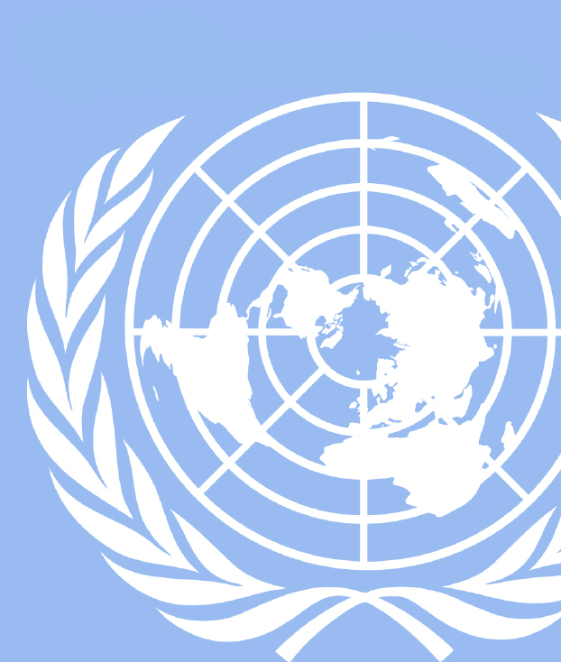
Hello Delegates,
UGAMUNC XXIV
African Union
Welcome to UGAMUNC XXIV! I would like to extend a personal welcome to both the new attendees and the returnees. Regardless of your skill level or how many conferences you have attended, we are thrilled to have you here and have the utmost confidence that you’ll excel at the conference. As delegates for the African Union, you will have the unique opportunity to gain a better understanding of the capacities and restraints that mold the policies of AU member states in addressing the challenges faced by the continent and its people. Further, we hope that this constructive debate will broaden your scope of understanding on issues in Africa and their global significance.
Seeing that we will be spending a lot of time together, it seems fitting that I share a little bit about myself. My name is Ashley Kalinda (ashleykalinda97@gmail.com) and I am currently in my second year at a beautiful institution I call home, but you may know as the University of Georgia (go dawgz, sic em’). My major area of study is International Affairs with African Studies as my minor. This is my second year participating in model United Nations and also my second year involved with UGAMUNC, after I was a co-chair for the General Assembly-3 last year. Apart from the UGA Model United Nations team, I also participate in the UNICEF organization on campus and I volunteer after school at the Downtown Academy. When I manage to find free time outside of school and extracurriculars, I like to attend concerts, watch Spoken Word competition videos, and stay updated on contemporary Twitter memes.
Your delightful co-chair will be Gustavo Cervantes (gcervantes@uga.edu). Gustavo is currently a sophomore at UGA majoring in Public Relations with a minor in Spanish. Gustavo has been involved in UGA Model United Nations for two years now, he is involved in UGA’s Public Relations Student Society of America club. Gustavo chaired the General Assembly-3 committee at UGAMUNC XXIII. In his free time Gustavo likes to eat Mr. Goodbars and play Marvel vs. Capcom 2.
In preparation for your debate, it is crucial to carefully read through this background guide and gain a general understanding of your country’s stance on policies in order to be equipped to find comprehensive solutions. The background guide is but the first step in your research from which each delegate will base their arguments, but it is not, in itself, a sufficient exposure to the intricacies of your committees’ topics. To maximize your experience as a delegate, we strongly encourage additional research on your country specifically. Should you have any questions regarding research, position papers, or clarification of the topics, please do not hesitate to contact either Gustavo or myself. Above all, we hope that you will find this to be a challenge you are excited to take on and we look forward to seeing you at the conference!

Until then,
Ashley Kalinda
Chair, AU

History of the African Union

The African Union is a regional organization of African states that was first established in 1999 as the successor of the Organization of African Unity. Structured in a similar manner to the European Union, the African Union’s many goals include ridding the continent of the last vestiges of colonization, promoting Unity among African States, safeguarding sovereignty of its member states, and promoting international cooperation within the framework of the United Nations.
The history of the African Union extends far before its establishment in 1999. The Organization of African Unity (OAU), the African Union’s predecessor, has roots as far back as the early 1900s. In a period of 1900 to 1927, increasing pan-African sentiment culminated in formation of five congresses that promoted black solidarity and protested colonization; however, these congresses were primarily composed of delegates from the West Indies and the United States. It was not until 1944 that black organizations founded the Pan African Federation, which sponsored resolutions that demanded political independence in the1950s, and new African states formed various political and economic organizations.
The throes of the African continent required a more serious organization of these states. In the first half of the 1960’s after some initial contention between more conservative and radical blocs of African states, an intermediary organization, the OAU was founded by 30 states; these 30 states turned into 53 states by the late 1990s. During this time the OAU adopted many resolutions to deal with contemporary problems including framework for unconstitutional changes, collective action to protect the environment, a treaty which established the African Economic Community, and eventually a call to form the African Union to re-organize and better implement policy that had started under the OAU.
The African Union has much in its own right that distinguishes it from the OAU that it originates from. For example, the AU Constitutive Act give the Union the, “right to intervene and a responsibility to protect in situations of war crimes, crimes against humanity, and genocide.” The African Union has also developed resolutions in its own right that have helped member states deal with some of their most dire issues. These initiatives include a declaration titled, “The Common African Position on the Proposed Reform of the United Nations: the Ezulwini Consensus”, which addresses issues relating to the HIV/AIDS as well as peacekeeping and trade negotiations among other broad factors; furthermore, the African Union has helped advocate for African representation in the United Nations, helping remind the UN that, “in 1945 when the UN was formed, most of Africa was not represented.”
I. Promoting Social and Economic Development in Postcolonial Africa

Introduction

The Oxford Dictionary defines post-colonialism as, “the political and cultural condition of a former colony.” In the context of states in the African Union, colonialism and its effects are still very tangible. To better understand the problems that states in the African Union face today, one frame that helps explain their causes is post-colonialism. European colonialism that was inflicted on the African continent most evidently in the 19th century, forever changed the face of the continent and how it was viewed by the global community. Internally, Africa was also forever marked by the age of European colonialism in ways that permanently changed the socioeconomic landscape of the continent. To understand the discourse of modern Africa, it is thus necessary to understand the problems that were directly imposed by colonialism and understand the contemporary repercussions of these problems, i.e., postcolonialism. For example, contemporary African scholars point out specifically that, “what we are witnessing [today] is a form of intensified colonialism which is ‘even more active now in the form of transnational corporatism.’” In this particular case, the tradition of economic exploitation that has historically affected Africa in the past can be seen today translated into the exploitative model of the modern transnational corporation. This economic problem and its relatedly generated social problems will be the front which this committee will work to uncover and remedy. When certain contemporary economic and social problems that plague African states are understood in a post-colonial context, their root cause is exposed and the solutions to these problems become more tangible. It is crucial to address the problems that have persisted as a direct result of European imperialism, which are as prevalent as ever. In this committee, it will be your responsibility to address the postcolonial problems that your state, as a member of the African Union, faces and still struggles with today, and in cooperation with fellow member nations, uncover solutions to these problems that help the African continent establish a post-colonial identity that synthesizes the problems that the state has dealt with in the past and moves forward into the modern geopolitical world with a more comprehensive of grasp on the problems that it has been dealt as a result of the European tradition of imperialism and colonialism.

Brief History of Colonialism in Africa

Colonialism warrants study due to how long it has impacted the continent of Africa. By the late 1400s, Europeans had set up trading posts in Africa; however, the exploitative narrative of imperial Europe did not take form until the late 1800s to the early 1900s. European interest in Africa dramatically changed as its various settlers began to uncover the continent’s abundant supply of natural resources; thus, by the 1870’s many rival European nations were frantically scrambling to colonize as much African territory as possible, which they had they completed successfully by the early 1880’s.

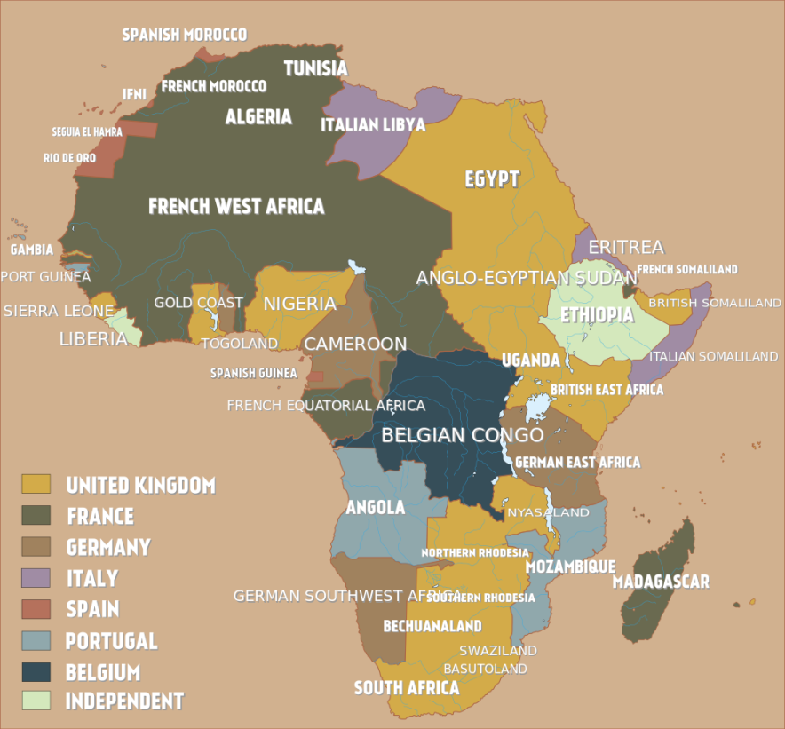
The rationale behind European expansion into Africa has been described as a culmination of over-production, surplus capital, and under-consumption in these industrialized nations along with a relatively peaceful political climate on the European continent itself. As it became apparent that powers of Europe were preparing to colonize Africa, German chancellor Otto von reBismarck held a diplomatic summit of European powers which became known the Berlin West Africa Conference, which was held from November 1884 to February 1885. The results of this conference (during which no African representatives were present) were ground rules that were laid out for the purpose of partitioning Africa; the European powers, having decided where and how they were to divide up the continent proceeded to do so, largely thanks to the technological advances of the Industrial Revolution and a transitional period in African governance and tribal politics. The result of what has largely become known to history as the “Scramble for Africa” can be seen in the picture of European land claims in Africa in the early 20th century, above. Having dominated the continent, the European powers established authoritative and bureaucratic regimes in order to micro-manage their newly-gained colonies. To conclude in brief, the damage caused to the people of the African continent was a result of a chaotic and unrelenting amount of war, authoritative governance, and the political cacophony that came from many different diverse peoples and cultures being suddenly geographically segmented into territories that were not of their own choosing. Even after these African states have developed into their own, self-governing nations, the imbalance created from this sudden period of chaos, war, and authoritarianism has birthed the problems that the African Union must address in the form of post-colonialism.
Source: Wikimedia Commons, “Colonial Africa 1913, pre WWI,” Accessed October 17, 2017 https://commons.wikimedia.org/wiki/File:Colonial_Africa_1913,_pre_WWI.svg

Economic Problems in Post-Colonial Africa

Traditional imperial control of African resources has complicated the economic development of African nations when dealing with post-colonial problems that many member states in the African Union face. The battle for economic independence plans in contemporary Africa has been historically characterized by two major issues, those being the struggle to reconstruct international relations in order to deter limitless domination of imperialist monopolies, and also asserting national sovereignty over domestic natural resources to effectuate radical social and economic transformation. These two major problems present major hurdles to many African Union member states. Mali for example, has had trouble stabilizing its international policy due to domestic problems caused by latent issues that originate from colonial annexation. In April of 2012, the Taureg tribe declared independence from Mali creating a short-lived nation named Azawad; Taureg created this state as a result of their nomadic tribe being spread out across the borders of Libya Mali, Niger, Burkina Faso, and Algeria. While these problems of political instability that are a result of European partition are not direct economic problems, they continue to present significant hurdles in African nations being able to gain sovereign control over their natural resources.

Another major factor affecting African Union member nations is continued economic interdependence on ex-colonial benefactors. African scholar Samuel Kidane identifies this problem:

Meanwhile, after independence most if not all newly independent African countries had opted for continuation of a semi-patronage bilateral relationship with their ex-metropolitan nations. In the attempt of historicizing the event Colin articulated it, as ex-British colonies were queued under the British common wealth of nations; ex-French colonies were under the Franco- phone community centered in London and Pairs respectively.

If the state cannot achieve some semblance of peace due to violent unrest within its various factions and also alleviate itself from continued economic interdependence from European colonial benefactors, then there is no stable political entity that can gain control of its natural resources and thus begin to recover from the ills of colonialism.

Social Problems in Post-Colonial Africa

Colonialism is a movement that also has, by nature of its totality, seeped into the social fabric of African culture. Starting with the missionary missions to Africa, which were complicated forces for change in the continent of their own, missionary Emory Ross who himself worked in Africa from 1912 to 1933 warned that the European ideals and realities of colonization mixed with attempts to Christianize the population would ultimately lead to, “grave dangers.” Among these dangers, he elaborates on a fear that the African population, upon rejection of the Christian ideals due to their association with the real ills of colonialism may lead the African populations to, “develop [their] own distortions of Christianity on the ground that if the West can warp that powerful religion to its own selfish and cultural ends, so can Africa.” Ross’ fear demonstrates that European ideals seem to have a character to them that made them alien to African culture and in danger of causing resistance and subversion upon their attempted implementation. As Iweriebor points out, the applications of assimilation onto African culture distorted pre-existing African political and social organizations and undermined their moral authority and political legitimacy. Thus, there is social theory showing that African social culture, injected with ideology that did not synchronize with its original source, was in the long term, negatively affected by European ideological colonization. This translates into contemporary problems when, “African governments somehow never deconstructed these colonial educational and epistemological systems, and therefore achieved success in the implementation of post-facto desired development goals.” Thus, problems arise when contemporary African Union member nations must unravel or form a coherent narrative that is built upon a mix of European ideals and African culture that is effective and helps push the society into a positive direction.

Past African Union Action

Post-Colonialism is a theoretical idea in political discussion of the contemporary state of the African Union, and thus is not often addressed directly by policy measures or resolutions. However, as described above, it seeps into a wide range of problems, specifically on the economic and social side. Many past policy implementations have met with challenges due to how deeply rooted the problems of European imperialism are for these African states. Some past action taken by the body that now represents the African Union includes the Treaty establishing the African Economic community in 1991 and the Cario Agenda for action issued in 1995 which aimed to relaunch Africa’s political, social and economic development. In a way, every issue that the African Union faces is inherently rooted in post-colonial reality. In preparation for debate, delegates are encouraged to identify the root post-colonial cause of economic and social development structures in their particular state in order to attempt to form holistic and comprehensive policy which addresses this issue at its core.

Questions to Consider

- What is the history of European colonialism in your state?
- What social or economic problems your state may be dealing with can be directly traced to the tradition of European imperialism?
- What solutions has your state or the African Union already implemented to deal with the most pressing social/economic problems in your state?
- Have current solutions to these pressing problems been successful, if not, what factors prevent these problems from being comprehensively solved?
- Can your state present resolutions that address post-colonial problems through effective acknowledgement of their root cause?

Suggested Readings

The Colonization of Africa
Ehiedu E.G. Iweriebor provides a streamlined and effective summary of the history of colonial tradition of Africa that can be read in under 10 minutes which concisely summarizes the “Scramble for Africa” through the perspective of European and African society.
- http://exhibitions.nypl.org/africanaage/essay-colonization-of-africa.html
The Economics of Pre and Post-Independence African Economy and the Possibility of Mainstreaming Meles’s Developmental State Ideologies
This article from Samuel Kidane does a fantastic job of describing historical tradition relating to the economic challenges that Africa faces that can be directly traced to colonialism. Kidane also provides suggestions for economic improvement in the continent.
- http://aigaforum.com/articles/The-Economics-of-Pre-and-Post-Independence-African-Economy.pdf
African Countries, Names, Colonial Names, and their Independence Days & Dates
This page is a great research starter, use it to find what empire had influence over your modern-day African Union state.
- http://www.myafricanow.com/african-countries-independence-days-dates/

II. Strengthening Counterterrorism Efforts in Response to al-Shabaab

Key Terms
Harakat Shabaab al-Mujahidin: commonly known as Al Shabab or Al Shabaab; means “the Youth” in Arabic; an Islamist militant group loosely affiliated with the courts founded in 2006.

Al Qaeda: a terrorist organization led by Osama bin Laden that began in the late 1980s; has merged with numerous other militant Islamist organizations; established training camps for Muslim militants across the world.

Islamic Courts Union (ICU): previously was a group of Sharia courts that united themselves to form a rival administration to the Transitional Federal Government of Somalia; was led by Sharif Sheikh Ahmed.

al Ittihad al Islamiyya (AIAI): founded in 1984 as a result of the merger of two Salafi organizations, Al Jama’a Al Islamiya and Wahdat Al Shabaab Al Islam; supports the creation of an Islamic state in the horn of Africa.

Shura Council: sometimes referred to as a “consultative council”; an advisory body that enabled the ICU and now the Al Shabaab; members consists of Al Shabaab leaders.

Transitional Federal Government (TFG): was previously the internationally recognized government of Somalia; intended to preside over a five-year period in elections, but faced opposition from clans, militias, Islamist leaders, and internal struggles.

African Mission in Somalia (AMSOM): an active, regional peacekeeping mission operated by the African Union with the approval of the United Nations.

Wahhabism: a puritanical form of Sunni Islam that is practiced most notably in Saudi Arabia and Qatar; generally considered as the most conservative Muslim group.

Sufism: mystical Islamic belief and practice in Muslims seek to find the truth of divine love and knowledge through direct personal experience with God.

Introduction
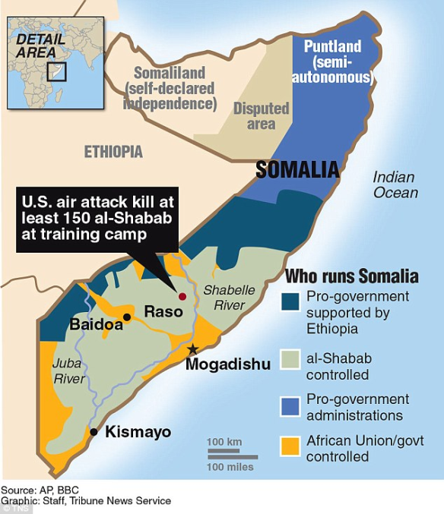
Al Shabaab is an Islamic fundamentalist militia in Somalia, located on the horn of Africa. Although the group primarily operates in southern and central Somalia, it has also launched terrorist attacks in neighboring countries also located in East Africa like the 2010 bombings in Kampala, Uganda and 2015 Garissa University college in northern Kenya. These countries have become targets for Al Shabaab because of their military and political support for Somalia’s Transitional Federal Government (TGF). The group poses a threat not only to the East African community, but it has also been brought to attention in Western nations as well given Al Shabaab’s widespread recruiting efforts. As a result of their growing recruitments, more and more nations have become concerned about the group’s agenda and maintaining global stability. Today, Al Shabaab is a combination of “locally focused Islamist insurgent group and a transnational terrorist affiliate of Al Qaeda”. It is difficult to fully configure Al Shabaab’s leadership structure but the group is formally led by Ahmed Abdi Godane and a shura consisting of both Somalis and outsiders.

History
Years of perpetual anarchy, widespread famine, and ongoing poverty have made Somalia the ideal recipient for the rise of radical Islamist groups. Al Shabaab initially emerged as a remnant of al-Ittihad al-Islami (AIAI), which worked to “create an Islamist emirate in Somalia”. In 1991, the fall of Siad Barre’s military regime and years of chaos that followed empowered AIAI, which at this had been considered a terrorist organization by the U.S. State Department. Conflict arose among the group when the AIAI’s old guard desired to create a new political elite while the younger members sought to implement fundamental Islamic rule. This ultimately led to the founding of Al-Shabaab in 2006 by the radical youth members of the now inoperative Islamic Courts Union (ICU). The ICU took control over the Somali capital Mogadishu after defeating local warlords and became an “alternative to the internationally recognized transitional government”. As a result of this and the growing concerns of the Transitional Federal Government, troops from Ethiopia intervened against the ICU and in support of the weak central government. Al-Shabaab advocates for the “Saudi-inspired” Wahhabi version of Islam which sets them apart from the majority of Somalis who are Sufis. Additionally, Al Shabaab maintains viewpoints that are contrary to the political position proposed by the TFG of Somalia. Despite this evidence, a general consensus has not been reached regarding Al Shabaab’s agenda and goals. Members of the group come from different clans and this allows room for disputes over “clan politics, internal divisions, and shifting alliances”. A majority of the fighters are concerned with the “nationalistic battle” against the TFG are not supportive of global jihad, however the older leaders continue to associate themselves with al-Qaeda. As a result of this growing relationship, Al Shabaab has enhanced its focus of suicide attacks, developing more training camps for suicide bombers across Somalia.

Past African Union Actions
The African Union Mission in Somalia (AMISOM) was created in 2007 as a response to the attacks by Al Shabaab and other armed militant groups. The mission was to protect the TFG, support the dialogue of reconciliation, and assist in implementing the National Security and Stabilization Plan for Somalia, carrying out operations against Al Shabaab and other actors that threatened the stability of the TFG. In the early years of the mission, Uganda and Burundi were the only nations who willfully contributed to troops while other countries were reluctant to due to the deteriorating security situation. By 2010, Al Shabaab had conducted two suicide bombings in Uganda with a death toll of over 74 people but instead of pulling the troops out of AMISOM, Uganda responded by deploying more troops. The United Nations Security Council later requested that the African Union enhance their numbers in the AMISOM force in order to ensure the mission’s capability to fulfil its mandate. A product of this action was the increase in troops to 10,000 and the TFG security forces were able to notably weaken the Al Shabaab and eventually, the militia group had retreated from Mogadishu in in 2011. The success of the AMISOM garnered attention from the U.S. Government who in 2012, gave $341 million to support the mission with equipment, logistical support and peacekeeping training to the Ugandan and Burundian peacekeepers through the Department of State’s Africa Contingency Operations Training and Assistance program. Despite the African Union’s ability to force Al Shabaab out of Somalia’s major cities, the militants still had jurisdiction over many towns and villages in the south and the group was able to prove this in 2013 when they attacked the Supreme Court complex in Mogadishu, killing over 30 people. To further enhance AMISOM’s military capacity, the United Nations Security Council requested to increase the number of troops again and since then, the mandate has been renewed every year. Despite the huge leaps forward that AMISOM was able to make, Al Shabaab still remains a significant threat in the horn of Africa and the group has continued to launch attacks in Mogadishu and according to the UN Monitoring Group, “retains capacity to launch attacks abroad”.

Questions to Consider
- Have certain methods of combatting Al Shabaab’s ability been more effective than others?
- Should efforts to counter Al Shabaab incorporate initiatives to reach out to non-violent Islamists to marginalize violent extremists? What could be potentials consequences of this strategy?
- How has my country been directly affected by terrorist organizations? What is my country currently doing to mitigate the efforts made by terrorist organizations?
- What are the drivers of violent extremism in the horn of Africa? How are they different from those in other regions that have experienced increased terrorist activity?
- What are some universal guidelines that can be put in place to stop groups like Al Shabaab from advancing?
- How have Al Shabaab’s abilities developed over time? Has it become stronger or weaker? What are some of the indicators?

Suggested Readings

Al-Shabab: An Interactive Timeline
This is a chronology of Al-Shabab’s key related events dating from 2004 to 2013.
- https://www.cfr.org/backgrounder/al-shabab
Civilian perspectives on the African Union Mission in Somalia
This source is based on field research directed by International Refugee Rights Imitative in Somalia, Kenya, and Uganda. The paper provides a good starting point in understanding the African Union Mission in Somalia and the role they’ve played in response to Al-Shabab’s attacks.
- http://refugee-rights.org/Publications/Papers/2017/AMISOM%20-%20final.pdf
Counterterrorism and Counterinsurgency in Somalia
This paper discusses the evolution of Al Shabaab and recommendations and strategic actions on combatting Al Shabaab. The website has a PDF file you can download for free to view the paper.
- https://www.rand.org/content/dam/rand/pubs/research_reports/RR1500/RR1539/RAND_RR1539.pdf

III. Increasing Accountability and Vigilance to Combat Electoral Corruption

Introduction

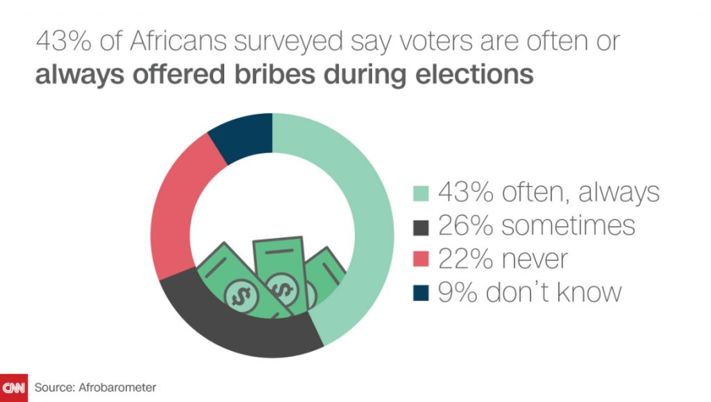
Corruption has become so entrenched in African society and the incentive to wrong by unlawful means has been slipped into a deterministic view of life. The electoral process in many African nations has been troubled for years and elections are often associated with vote-buying, harassment and intimidation of political opponents. Africa has had a long history of voter manipulation which has been entrenched in people’s memories. Lack of transparency of election monitoring bodies and corruption all influence people’s trust in the system and many people have become afraid when casting their votes. There is a need for African nations to strengthen their institutions that are in charge of holding governments accountable along with providing electoral systems that permit citizens to re-elect candidates or choose alternatives freely. This idea of “accountability” means that elections should be held to keep governments responsible previous actions in order to constrain politician’s corrupt behavior. It is crucial that the citizens and civil societies continue to push for elections and that the global community allocates significant technical and diplomatic resources to encourage fair electoral processes in Africa.

History

Merely two decades after African nations obtained independence from their former European colonists, the scale of Western political discourse looked favorably upon the system of dictatorship. The development process of becoming a state resulted in an authoritarian top down approach to government and nearing the end of the 1970s, African authoritarian governments’ ability to “deliver their developmental objectives” became apparent. Under colonial rule, states were military and administrative entities, practically solely intended to exploit resources in the colonizers favor. Nonetheless, the colonial states were weak and since there was little concern for the improvement of the masses’ condition of life, little effort was made in interacting with the African societies. As a result of this, the period of colonialism “saw the development of a state based on domination rather than legitimacy and an authoritarian political culture that considered violence patronage and corruption as normal tools of maintaining control over a population”. These malpractices were adapted by the African leaders after independence and the governing structure of coercion was kept intact.

The sheer objective of the Europeans was to capitalize on the African resources so the system of administration was inherently undemocratic. The European colonial authoritarians “made decisions on behalf of the indigenous population without taking into account their idea or consulting them” and this monopolized system is what set the stage for an autocratic rule. Africa was exposed to multiparty systems but this was not genuinely practiced because the political environment was not conducive to compete and often times, opposition political parties in Africa are “banned, criminalized their activities or undermined their contribution to national policy”. Not only did European colonizers leave merely a precedent for authoritarian and one party rule, but they failed to prepare African nations for postcolonial autonomy and many countries did not have proper institutions in place for government. For instance, when the Democratic Republic of Congo gained independence from Belgium, the country only had 16 people who had earned any type of university degree. The state paid particular attention to its extractives duties and built expert industrial infrastructure. However, sectors like health and education were entirely ignored. In 1980, Zimbabwe's current President Robert Mugabe was elected as the first prime minister of the reconstituted state of Zimbabwe after only being trained as a teacher in the Catholic Church. Mugabe had a promising start, improving access to education and health care but this was all overshadowed by his following alleged widespread election fraud, economic embezzlement, and constant amendments to the constitution to ensure his never-ending position in power. Politicians in power refusing to leave their seats is a recurring issue in the continent that has also been in Equatorial Guinea following independence. Equatorial Guinea’s president Teodoro Obiang Nguema Mbasogo took power in 1979 after ousting his uncle in a bloody coup d'état. Nguema is now the longest serving ruler in Africa and is often accused having authority in “one of the world's most corrupt and repressive governments”.

Past African Union Actions
In response to widespread fraudulent conduct across the continent, the African Union adopted the African Union convention on Preventing and Combating Corruption in July of 2003. The Convention is intended to represent regional consensus on what the African states should aim towards executing in areas of “prevention, criminalization, international cooperation and asset recovery”. Some of the offenses that are addressed on the Convention include “bribery (domestic or foreign), diversion of property by public officials, trading in influence, illicit enrichment, money laundering and concealment of property and primarily consists of mandatory provisions”. In 2007, the following nine countries had yet to have fully implemented international corruption conventions: Algeria, Burundi, Kenya, Liberia, Nigeria, Sierra Leone, South Africa, Togo, and Uganda. Those nine countries were said to “have legal gaps with regards to the provisions of the United Nations Convention against Corruption (UNCAC) and the African Union (AU) Convention on Preventing and Combating Corruption and Related Offences”. Within the African Union, an autonomous organ was established in May of 2009, called the African Union Advisory Board Corruption in terms of Article 22 of the UNCAC. The Board’s anti-corruption initiatives promote and encourage the adoption of actions by Member States to “prevent, detect, punish and eradicate corruption and related offences in Africa” in attempt to create international law on corruption in the continent, as there is no comprehensive international law regarding the issue.

Questions to Consider

- Have elections in my state ever been called into question? Have any of our elections been monitored in the past?
- Further, if there is electoral corruption within my state, what means are most common in committing this fraud?
- What are some provisions that will ensure that member states be held accountable for practicing free and fair elections?
- How should current African governments that are abetting corruption be dealt with? Should actors involved be prosecuted criminally?
- How can African governance increase their transparency?

Suggested Readings

AU ABC Strategic Plan 2011-2015
This is the plan conducted by the African Union Advisory Board on Corruption. It provides a good framework for comprehending the African Union’s capabilities on the issue of corruption and further displays ways they’ve tried addressing it in the past.
- http://www.auanticorruption.org/resources/view/au-abc-strategic-plan-2011-2015

Fighting Corruption Seriously? Africa’s Anti-corruption Convention
This paper is on fighting corruption in Africa and the need for international cooperation in order to combat this form of organized crime. The document is rather long but there are sub-topics in there that you might find useful regarding your country’s stance on the certain issues.
- http://www.commonlii.org/sg/journals/SGJlIntCompLaw/2003/17.pdf

Why Africa Leaders Are Refusing To Give Up Power
This video talks about how post colonialism has played a huge role in the corrupt governments that currently exist in Africa and how African leaders across the continent are continually refusing to leave office.
- https://www.youtube.com/watch?v=6EgytdOWnk8

Bibliography

""They Say They're Not Here to Protect Us.": Civilian perspectives on the African Union Mission in Somalia." Terrorism and Counter-Terrorism in Africa (2017).
Abdi, Ali, A. "Decolonizing Educations and Social Development Platforms in Africa." African and Asian Studies (2013). Journal.
AEI. Al Shabaab leadership profiles. 14 November 2011. 17 October 2017. <www.aei.org/publication/al-shabaab-leadership-profiles/>.
Ahluwalia, Pal. "Chapter 6: Globalisation and post-colonialism." In Politics & Post-Colonial Theory. Taylor & Francis Ltd. Books, 2000. 113-131.
Al Jazeera. Equatorial Guinea election: Incumbent expected to win. 24 April 2016. Web. 18 October 2017. <http://www.aljazeera.com/news/2016/04/equatorial-guinea-election-160424044551251.html>.
—. Timeline: Al-Shabab violence. 30 August 2010. <http://www.aljazeera.com/news/africa/2010/08/201082416759655666.html>.
AMISOM. AMISOM Background. n.d. <www.amisom-au.org/amisom-background>.
AU in a Nutshell. n.d. The African Union Comission. Web. 15 October 2017. <https://au.int/en/history/oau-andau>.
Bayeh, Endalcachew. "THE POLITICAL AND ECONOMIC LEGACY OF COLONIALISM IN THE POST-INDEPENDENCE AFRICAN STATES." International Journal in Commerce, IT & Social Sciences 2 no.2 (2015). 14 October 2017.
BBC News. Equatorial Guinea profile - Leaders. 23 December 2014. 18 October 2017. <http://www.bbc.com/news/world-africa-13317176>.
—. Who are Somalia's al-Shabab? 9 December 2016. <http://www.bbc.com/news/world-africa-15336689>.
Blanchard, Christopher M. The Islamic Traditions of Wahhabism and Salafiyya. 24 January 2008. <https://fas.org/sgp/crs/misc/RS21695.pdf>.
Cassman, Daniel. "Al Ittihad Al Islamiya." Al Ittihad Al Islamiya | Mapping Militant Organizations (n.d.). 17 October 2017.
Chazan, N. Lewis, P. Mortimer, R.A, Rotchild D. Stedman. "Politics and Society in Contemporary Africa." (1999). 12 October 2017.
E.V., Transparency International. TI country studies in Africa: commitment to anti-corruption conventions still weak. n.d. Web. 18 October 2017. <https://www.transparency.org/news/pressrelease/20070417_ti_country_studies_in_africa_commitment_to_anti_corruption_convent>.
Encyclopædia Britannica Inc. Al Qaeda. 14 October 2016. Web. 17 October 2017. <https://www.britannica.com/topic/al-Qaeda>.
Funk & Wagnalls New Encyclopedia. African Union. 2016. Encylopedia.
Guide, Counter Terrorism. AL-SHABAAB. n.d. 17 October 2017. <https://www.dni.gov/nctc/groups/al_shabaab.html>.
History.com. Robert Mugabe. 2009. Web. 18 October 2017. <http://www.history.com/topics/robert-mugabe>.
Hobbs, Nicole. The UN and the Congo Crisis of 1960. 2014. Web. <http://elischolar.library.yale.edu/cgi/viewcontent.cgi?article=1006&context=applebaum_award>.
Iweriebor, Ehiedu E. G. "The Colonization of Africa. 2011. Web. 17 October 2017. <www.exhibitions.nypl.org/africanaage/essay-colonization-of-africa.html>.
Kidane, Samuel. "The Economics of Pre and Post-Independence African Economy and the Possibility of Mainstreaming Mele's Developmental State Ideologies." (n.d.). <http://aigaforum.com/articles/The-Economics-of-Pre-and-Post-Independence-African-Economy.pdf>.
Mann, Michael. "Post-Colonial Development in Africa ." Foreign Policy Journal (2012).
Mayallah, Elisha. Africa: AU Calls for Anti-Corruption Day. 21 June 2016. Web. 18 October 2017. <http://allafrica.com/stories/201606210191.html>.
Middleton, Jon. "Colonialism in Africa." Africa: An Encylcopedia for Students. Vol. I. Charles Scribner's Sons, 2002. 151-167.
Murithi, Tim. "Briefing: The African Union at Ten: An appraisal." African Affairs 111 2012: 662-669.
Oxford University Press. Postcolonialism. n.d. Web. 15 October 2017. <https://en.oxforddictionaries.com/definition/postcolonialism>.
Pike, John. African Union Mission in Somalia. n.d. 18 October 2017. <https://www.globalsecurity.org/military/world/int/amisom.htm>.
Ploch, Lauren. "Countering Terrorism in East Africa: The U.S. Response." Congressional Research Service (2010).
Ross, Emory. "Impact of Christianity in Africa." (1955). <journals.sagepub.com/doi/pdf/10.1177/000271625529800117>.
Schimmel, Annemarie. Sufism. 17 July 2017. Encyclopædia Britannica. Web. 17 October 2017.
Tarrósy, István, Lorand Szabo, and Goran Hyden. "The African state in a changing global context breakdowns and transformations." Berlin: LIT Verlag Münster 2011.
Uzoigwe, G. N. Africa under Colonial Domination. Vol. VII. University of California Press, 1985.
Yan, Holly. What is Al-Shabaab, and what does it want? 2 April 2015. Web. 17 October 2017. <http://www.cnn.com/2015/04/02/world/africa/al-shabaab-explainer/index.html>.

“AU in a Nutshell” The African Union Commission, Accessed October 15, 2017, https://au.int/en/history/oau-and-au
Ibid
2016. "African Union." Funk & Wagnalls New World Encyclopedia 1p. 1. Funk & Wagnalls New World Encyclopedia
Ibid
Ibid
“AU in a Nutshell” The African Union Commission, Accessed October 15, 2017, https://au.int/en/history/oau-and-au
Murithi, Tim. 2012. "Briefing: The African Union at Ten: An appraisal." African Affairs 111, no. 445: 662-669. Academic Search Complete, EBSCOhost (accessed October 15, 2017).
Ibid
“Postcolonialism,” Oxford University Press, Accessed October 15, 2017, https://en.oxforddictionaries.com/definition/postcolonialism
Ahluwalia, Pal, 2000, "Chapter 6: Globalisation and post-colonialism." In Politics & Post-Colonial Theory, 113-131. n.p.: Taylor & Francis Ltd / Books, 2000
Middleton, Jon, 2002, “Colonialism in Africa” Africa: An Encyclopedia for Students, vol. 1, pp.151-167, Charles Scribner’s Sons
Ibid
G. N. Uzoigwe, “Africa under Colonial Domination,” vol. 7, University of California Press, 1985
Ehiedu E. G. Iweriebor, “The Colonization of Africa,” Schomburg Center for Research in Black Culture, 2011, Accessed October 17, 2017, http://exhibitions.nypl.org/africanaage/essay-colonization-of-africa.html
Ibid
Ibid
Samuel Kidane, “The Economics of Pre and Post-Independence African Economy and the Possibilities of Mainstreaming Mele’s Developmental State Ideologies,” Accessed October 17, 2017, http://aigaforum.com/articles/The-Economics-of-Pre-and-Post-Independence-African-Economy.pdf
Michael Mann, “Post Colonial Development in Africa,” Foreign Policy Journal, June 3, 2012, Accessed October 17, 2017, https://www.foreignpolicyjournal.com/2012/06/03/post-colonial-development-in-africa/
Samuel Kidane, “The Economics of Pre and Post-Independence African Economy and the Possibilities of Mainstreaming Mele’s Developmental State Ideologies,” Accessed October 17, 2017, http://aigaforum.com/articles/The-Economics-of-Pre-and-Post-Independence-African-Economy.pdf
Emory Ross, “Impact of Christianity in Africa,” Sage Publications Inc., 1955, Accessed October 18, 2017, journals.sagepub.com/doi/pdf/10.1177/000271625529800117
Ibid
Ehiedu E. G. Iweriebor, “The Colonization of Africa,” Schomburg Center for Research in Black Culture, 2011, Accessed October 17, 2017, http://exhibitions.nypl.org/africanaage/essay-colonization-of-africa.html
Ali A. Abdi, “Decolonizing Educational and Social Development Platforms in Africa” African and Asian Studies, 2013, Accessed October 18, 2017
“AU in a Nutshell” The African Union Commission, Accessed October 15, 2017, https://au.int/en/history/oau-and-au
"AL-SHABAAB." Counter-Terrorism Guide. Accessed October 17, 2017. https://www.dni.gov/nctc/groups/al_shabaab.html.
The Editors of Encyclopædia Britannica. "Al-Qaeda." Encyclopædia Britannica. October 14, 2016. Accessed October 17, 2017. https://www.britannica.com/topic/al-Qaeda.
Tarrósy, István, Lorand Szabo, and Goran Hyden. The African state in a changing global context breakdowns and transformations. Vol. 42. African studies. Berlin: LIT Verlag Münster, 2011.
Cassman, Daniel. "Al Ittihad Al Islamiya." Al Ittihad Al Islamiya | Mapping Militant Organizations. Accessed October 17, 2017.
"Al Shabaab leadership profiles." AEI. November 14, 2011. Accessed October 17, 2017. www.aei.org/publication/al-shabaab-leadership-profiles/.
Ploch, Lauren. "Countering Terrorism in East Africa: The U.S. Response." Congressional Research Service, November 3, 2010. Accessed October 16, 2017.
AMISOM Background." AMISOM. Accessed October 17, 2017. “AMISOM Background Historique de l'AMISOM Aasaaska AMISOM.” AMISOM, amisom-au.org/amisom-background/.
Blanchard, Christopher M. "The Islamic Traditions of Wahhabism and Salafiyya." CRS Report for Congress, January 24, 2008. Accessed October 17, 2017. https://fas.org/sgp/crs/misc/RS21695.pdf.
Schimmel, Annemarie. "Sufism." Encyclopædia Britannica. July 17, 2017. Accessed October 17, 2017. https://www.britannica.com/topic/Sufism.
"Al Shabab." The Columbia Encyclopedia, 6th ed.. . Encyclopedia.com. (October 16, 2017). http://www.encyclopedia.com/reference/encyclopedias-almanacs-transcripts-and-maps/al-shabab
Jazeera, Al. "Timeline: Al-Shabab violence." News | Al Jazeera. August 30, 2010. Accessed October 16, 2017. http://www.aljazeera.com/news/africa/2010/08/201082416759655666.html.
Ploch, Lauren. "Countering Terrorism in East Africa: The U.S. Response." Congressional Research Service, November 3, 2010. Accessed October 16, 2017. https://fas.org/sgp/crs/terror/R41473.pdf.
ibid
Yan, Holly. "What is Al-Shabaab, and what does it want?" CNN. April 02, 2015. Accessed October 17, 2017. http://www.cnn.com/2015/04/02/world/africa/al-shabaab-explainer/index.html.
ibid
ibid
ibid
"Who are Somalia's al-Shabab?" BBC News. December 09, 2016. Accessed October 17, 2017. http://www.bbc.com/news/world-africa-15336689.
ibid
Jazeera, Al. "Timeline: Al-Shabab violence." News | Al Jazeera. August 30, 2010. Accessed October 16, 2017. http://www.aljazeera.com/news/africa/2010/08/201082416759655666.html.
"Who are Somalia's al-Shabab?" BBC News. December 09, 2016. Accessed October 17, 2017. http://www.bbc.com/news/world-africa-15336689.
Ploch, Lauren. "Countering Terrorism in East Africa: The U.S. Response." Congressional Research Service, November 3, 2010. Accessed October 16, 2017. https://fas.org/sgp/crs/terror/R41473.pdf.
"AL-SHABAAB." Counter-Terrorism Guide. Accessed October 17, 2017. https://www.dni.gov/nctc/groups/al_shabaab.html.
ibid
ibid
""They Say They're Not Here to Protect Us.": Civilian perspectives on the African Union Mission in Somalia." Terrorism and Counter-Terrorism in Africa, May 31, 2017. Accessed October 17, 2017.
ibid
ibid
Pike, John. "African Union Mission in Somalia." GlobalSecurity. Accessed October 18, 2017. https://www.globalsecurity.org/military/world/int/amisom.htm.
ibid
""They Say They're Not Here to Protect Us.": Civilian perspectives on the African Union Mission in Somalia." Terrorism and Counter-Terrorism in Africa, May 31, 2017. Accessed October 17, 2017.
ibid
André Mbata Mangu, "The African Union and the promotion of democracy and good political governance under the African Peer-Review Mechanism: 10 years on," Africa Review, March 3, 2014, , accessed October 10, 2017, http://www.tandfonline.com/doi/pdf/10.1080/09744053.2014.883757.
ibid
Chazan, N. Lewis, P. Mortimer, R.A, Rotchild D. Stedman, S.D. 1999. “Politics and Society in Contemporary Africa”, Lynne Rienner Publisher, London , accessed October 12, 2017
ibid
Endalcachew Bayeh, "THE POLITICAL AND ECONOMIC LEGACY OF COLONIALISM IN THE POST-INDEPENDENCE AFRICAN STATES," International Journal in Commerce, IT & Social Sciences 2, no. 2 (February 2015): , accessed October 14, 2017.
ibid
Nicole Hobbs, "The UN and the Congo Crisis of 1960," Harvey M. Applebaum '59 Award, 2014, , accessed October 14, 2017, http://elischolar.library.yale.edu/cgi/viewcontent.cgi?article=1006&context=applebaum_award.
"Robert Mugabe." History.com. 2009. Accessed October 18, 2017. http://www.history.com/topics/robert-mugabe.
"Equatorial Guinea profile - Leaders." BBC News. December 23, 2014. Accessed October 18, 2017. http://www.bbc.com/news/world-africa-13317176.
Jazeera, Al. "Equatorial Guinea election: Incumbent expected to win." News | Al Jazeera. April 24, 2016. Accessed October 18, 2017. http://www.aljazeera.com/news/2016/04/equatorial-guinea-election-160424044551251.html.
Mayallah, Elisha. "Africa: AU Calls for Anti-Corruption Day." AllAfrica.com. June 21, 2016. Accessed October 18, 2017. http://allafrica.com/stories/201606210191.html.
ibid
E.V., Transparency International. "TI country studies in Africa: commitment to anti-corruption conventions still weak." Transparency. Accessed October 18, 2017. https://www.transparency.org/news/pressrelease/20070417_ti_country_studies_in_africa_commitment_to_anti_corruption_convent.
ibid
Mayallah, Elisha. "Africa: AU Calls for Anti-Corruption Day." AllAfrica.com. June 21, 2016. Accessed October 18, 2017. http://allafrica.com/stories/201606210191.html.
ibid

