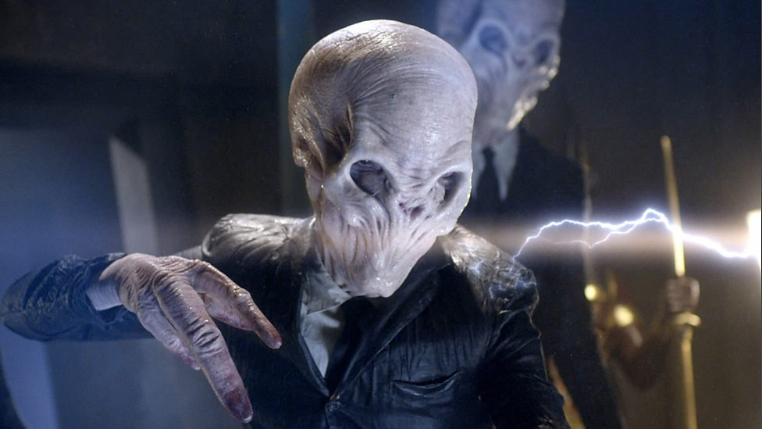
The Silence
Occupation: Brings about terror upon sight; mental manipulation
Picture obtained from http://www.bbc.co.uk/programmes/p00sg75s/p00nmzrd

The Silence
Religious Order Leader
Base: The Church

Not only does The Silence want to know where Doctor Who is, but The Silence also wants to know who the Doctor truly is. It seems obvious to them that if we are having to search for the Doctor that there is perhaps something he is running from. Notorious for their evil deeds, The Silence has also been known to get along with Madame Kovarian and Tasha Lem, and more often than not with bad intentions for the Doctor. The Silence has been silenced for so long, but that means that he/she has been able to gather much information. Perhaps they may be able to reach out to a past ally to confirm some secrecy, and finally be able to speak their minds (whether it be for good for evil).
*Note: The Silence is given sentient thought and talking ability*

"The Silence." Tardis Data Core . Fandom , 16 Apr. 2014. Web. 10 Jan. 2017.
http://tardis.wikia.com/wiki/The_Silence

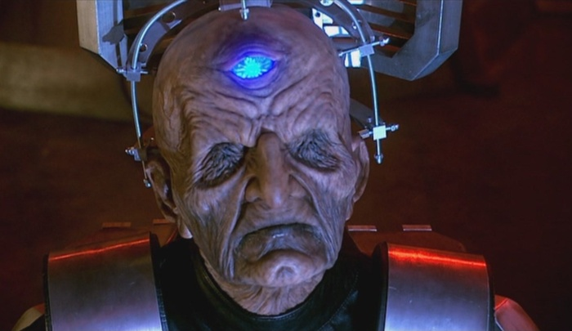
Davros
Occupation: Dalek’s Creator/Emperor; Wager of war
Picture obtained from http://tardis.wikia.com/wiki/Davros

Davros
Dalek’s Creator/Emperor; Wager of war
Base: Skaro

Child of both Lady Calcula and Councillor Quested, Davros is a character of both brains and strength. Davros is known for the killing of me and has many enemies across space and time. Davros is an extremely talented scientist and creator. Lacking complete acceptance and respect from his family, Davros sought to be a person respected and looked up to by many. Davros isn’t particularly fond of the Doctor, but he has respect for him as well as they have had previous interactions and encounters. Davros is known to be a major antagonist to the Doctor, so the choice is up to you… Will you, as Davros, use your Dalek army to help or to hinder the hunt? Happy searching.

"Davros." Tardis Data Core . Fandom , 21 Sept. 2015. Web. 11 Jan. 2017.
http://tardis.wikia.com/wiki/Davros

Vashta Nerada 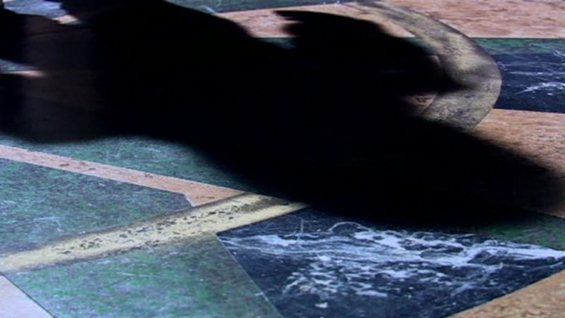
Naturally occurring all around the universe, Vashta Nerada are as small as dust, but can swarm together and take form/control things as a pack. They can strip the meat from the bones of victims in seconds and even take over their space suits once inside. In swarm they can speak sentiently. For this committee, they will be in swarm and sentient. They are found in every dark space in the universe, and they will not go into light, unless swarmed inside of a space suit. They understand their existence depends on The Doctor’s return.
Picture and text: http://tardis.wikia.com/wiki/Vashta_Nerada

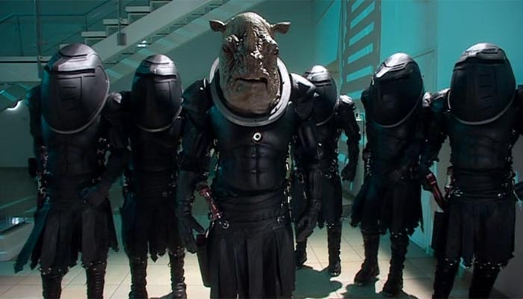
Judoon
Occupation: Mercenaires; Police Force
Picture obtained from http://tardis.wikia.com/wiki/Judoon

Judoon
Mercenaries; Police Force
Base: Judoonia

Although lacking a large brain, the Judoon makes up for it with his/her large human/rhino body type. The Judoon is an extremely loyal and methodological character, for the Judoon lives to work and to not stop with their force or carrying out their task until it is completely finished. The Judoon has a special power in the fact that it can scan whomever or whatever it is in close contact with, although many try to meddle with this. As a ruthless character, a Judoon will systematically kill what is necessary in its sight. Although a Judoon may not always be able to connect the dots, he/she is able to resist many types of environments and will serve (if used for good) as an extremely important and dependable asset.
*Note: Given full speaking ability*

"Judoon." Tardis Data Core . Fandom , 18 Apr. 2013 . Web. 11 Jan. 2017.
http://tardis.wikia.com/wiki/Judoon

Jabe, Tree of Cheem 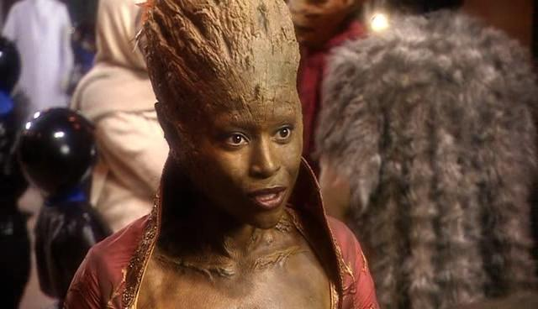
She is the representative from the Forest of Cheem. Her people are the ancestors were plants in the tropical rainforests on Earth. Her people were witness to the Great Time War. She only knew the ninth Doctor for a brief time, but she left a lasting impression. She understands that he is the last of his kind and his powers and existence is a necessity for all of time and space. In the year 5,000,000,000, she gave her life to help The Doctor to save the ship. Jabe will stop at nothing to help save the entire Universe.
http://tardis.wikia.com/wiki/Tree_of_Cheem
Picture: http://tardis.wikia.com/wiki/Jabe

The Fisher King 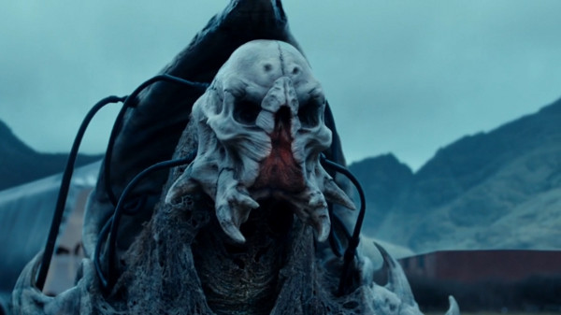
A truly sinister character, he conquered the Tivolians and ruled them before supposedly dying. He was not really dead, but in stasis. He killed people and turned them into ghost who transmit a signal of his locations so that his people could come save him. He is absolutely evil normally, but in these darker times, he is setting his evil ways to the side in order to save the universe he wants to rule.
Photo and text: http://tardis.wikia.com/wiki/Fisher_King

